Rothko Breaks a Record for Contemporary Art
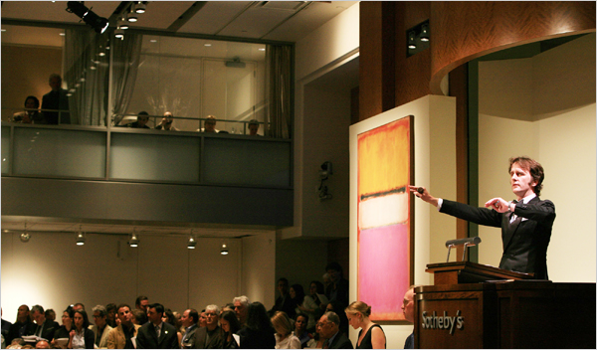
Liz Baylen for The New York Times
The auctioneer Tobias Meyer with Rothko's “White Center (Yellow, Pink and Lavender on Rose).”
Top of Form
By CAROL VOGEL
Published: May 16, 2007
The Rockefeller name worked its magic last night at Sotheby’s sale of contemporary art, where a mysterious bearded collector in a skybox outbid five other contenders for Rothko’s “White Center (Yellow, Pink and Lavender on Rose).” The $72.8 million he paid, far above the painting’s $40 million estimate, set records for both the artist and for any contemporary work at auction.
Sotheby’s declined to say who the buyer was or where he was from. But the seller was David Rockefeller, the retired banker and chairman emeritus of the Museum of Modern Art, who had decided to cash in on the market and invest the money in other philanthropic endeavors.
Seasoned auctiongoers noticed that last night rubles appeared for the first time on the salesroom’s currency board, along with dollars, euros, pounds and Swiss francs — an indication of the strong presence of big-spending Russians in the art market.
The price for the Rothko, an abstract canvas from 1950 dominated by a block of hot pink, was the climax of a spirited evening when already inflated prices for contemporary art rose yet again. In addition to Rothko, records were set for artists living and dead, from Francis Bacon and Morris Louis to Richard Prince and Cecily Brown.
Of the 74 lots, only nine failed to sell. The sale totaled $254.8 million, just shy of its $265 million high estimate.
Sotheby’s had gambled that the market for contemporary art would continue to rise this week, and it did. The auction house also worked overtime promoting paintings like the Rothko in which it had invested heavily. For months the company had been relentlessly marketing the Rothko, advertising it heavily, sending it to art capitals, inviting mega-rich collectors to private viewings and even offering collectors the opportunity to hang it in their homes, as if trying on a piece of couture.
Potentially, the auction house had a lot to lose. To capture market share away from its archrival, Christie’s, and to persuade Mr. Rockefeller to sell the painting at Sotheby’s, it had to make a serious financial investment. Experts familiar with the negotiations said the auction house had given Mr. Rockefeller a guarantee — an undisclosed minimum sum promised to a seller regardless of a sale’s outcome — of $46 million, as well as a hefty portion of the fee it charges buyers. The $40 million estimate for the Rothko was nearly twice the previous auction record for a painting by the artist: $22.4 million paid at Christie’s in 2005. Mr. Rockefeller bought the painting in 1960 for less than $10,000.
Another record price was paid last night for Francis Bacon’s “Study From Innocent X” (1962). The first painting in his series based on Velázquez’s “Portrait of Pope Innocent X” (1650), the rich red canvas is a full-length version of one of Bacon’s signature contorted characters. It was estimated at $30 million, more than the record $27.5 million for a Bacon paid at Christie’s in London in February. That record nearly doubled when another unidentified telephone bidder paid $52.6 million.
(Final prices include Sotheby’s commission: 20 percent of the first $500,000 and 12 percent of the rest. Estimates do not reflect commissions.)
Few museums are sellers this season. One exception was the Israel Museum in Jerusalem, which last night parted with an untitled 1981 Basquiat showing a primitive figure with clenched teeth, his oversized hands held high in the air. The painting was estimated at $6 million to $8 million. Those familiar with the consignment say the auction house gave the museum an $8 million guarantee. Again, Sotheby’s gambled well. Six bidders went after the painting, which sold to yet another unidentified telephone bidder for $14.6 million, nearly triple the previous $5.5 million record set at Christie’s in 2002 . The New York collectors Barbara and Eugene Schwartz bought it for $3,150 the year it was painted; four years later they gave it to the Israel Museum, which was selling it to create an endowment fund to buy more contemporary art.
Pop Art was a particularly big seller. Tom Wesselman, an undervalued Pop master, broke a record when a telephone bidder paid $5.8 million for “Smoker No. 17” (1975), from the artist’s series of shaped canvases that zoom in on a woman’s disembodied mouth smoking a cigarette. The high estimate was $4.5 million.
A classic 1964 Warhol of a Campbell’s soup can brought $5.5 million, far above its $4.5 million high estimate. The buyer was Rory Howard, a Manhattan dealer.
Works that didn’t sell had unappealing subjects, were overpriced or had simply been on the market too recently. Three Pollocks were among the evening’s casualties, because of both the aggressive estimates and their market histories, experts said.
Among living artists in demand was the Scottish-born painter Peter Doig. Last year Sotheby’s made a deal with the advertising mogul Charles Saatchi to buy seven works by Mr. Doig for a total of $11 million, and last night one of them was up for sale: “The Architect’s Home in the Ravine,” a 1991 painting that is the first of a series showing buildings in their landscapes. Estimated at $1.2 million to $1.8 million, it sold to a telephone bidder for $3.6 million. While the price may have seemed high, in February Sotheby’s in London auctioned off “White Canoe,” another painting by Mr. Doig from Mr. Saatchi’s collection, to a telephone bidder, who experts said was a new Russian buyer, for $11.2 million, a record for the artist.
After the sale, as the audience was milling outside Sotheby’s, many were trying to make sense of the high prices, especially the $72.8 million for the Rothko. Was it the Rothko or the provenance that pushed the price so high?
“It was a combination of both,” said Lucy Mitchell-Innes, a Manhattan dealer. Nicholas Maclean, another Manhattan dealer, said he thought someone had “just bought a Rockefeller.”

