coursera.org

AUGUST 19, 2014

Statement of Accomplishment

WITH DISTINCTION

D AVID JOFFE

HAS SUCCESSFULLY COMPLETED THE JOHNS HOPKINS UNIVERSITY'S OFFERING OF

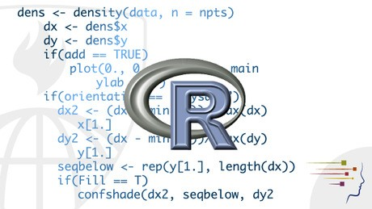R Programming

This course covers how to use & program in R for effective data analysis. It covers practical issues in statistical computing: programming in R, reading data into R, accessing R packages, writing R functions, debugging, profiling R code, & organizing and commenting R code.

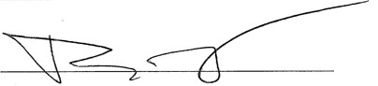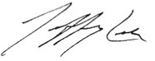ROGER D. PENG, PHD
DEPARTMENT OF BIOSTATISTICS, JOHNS HOPKINS BLOOMBERG SCHOOL OF PUBLIC HEALTH
JEFFREY LEEK, PHD
DEPARTMENT OF BIOSTATISTICS, JOHNS HOPKINS BLOOMBERG SCHOOL OF PUBLIC HEALTH

BRIAN CAFFO, PHD, MS
DEPARTMENT OF BIOSTATISTICS, JOHNS HOPKINS BLOOMBERG SCHOOL OF PUBLIC HEALTH

PLEASE NOTE: THE ONLINE OFFERING OF THIS CLASS DOES NOT REFLECT THE ENTIRE CURRICULUM OFFERED TO STUDENTS ENROLLED AT THE JOHNS HOPKINS UNIVERSITY. THIS STATEMENT DOES NOT AFFIRM THAT THIS STUDENT WAS ENROLLED AS A STUDENT AT THE JOHNS HOPKINS UNIVERSITY IN ANY WAY. IT DOES NOT CONFER A JOHNS HOPKINS UNIVERSITY GRADE; IT DOES NOT CONFER JOHNS HOPKINS UNIVERSITY CREDIT; IT DOES NOT CONFER A JOHNS HOPKINS UNIVERSITY DEGREE; AND IT DOES NOT VERIFY THE IDENTITY OF THE STUDENT.

