Mobility in Montepulciano
From http://politianapartments.blogspot.com/
Montepulciano is a small town but given its geography its quite hard to climb its steep streets.
Luckily there is a service of public transportation supplied by a small bus nicknamed "Pollicino"
These orange buses run loops around the town and its suburbs and are especially handy to lift you up from the lower parts of the town to the top of the hill.
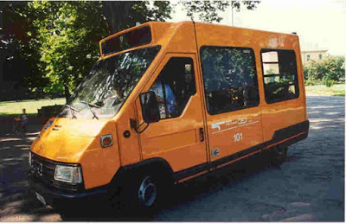
how the bus Pollicino looks like
There are several stops along the main streets which take the name from major places.
Here the maps of all stops
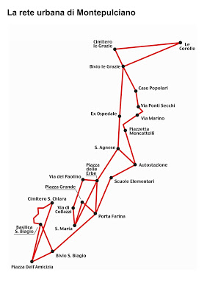
You can by the hourly ticket at the price of 1,10 EUR from local shops (i.e bar) and online trough this website: http://www.tiemme.tpl.busweb.it/urbano
You need to sign up first so you can easily pay online anytime you need a ticket and receive it on your email. You need either to print it or carry the electronic format on your device (phone, ipad etc).
Unfortunately the website is only in Italian but you can see the below picture how to set the website to buy a single ticket (valid for 60 min)
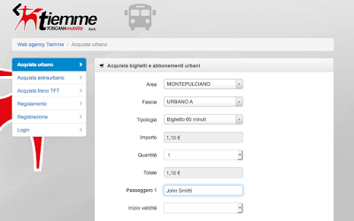
You can also buy a daily ticket (select BIGLIETTO GIORNALIERO) or a monthly ticket (select ABBONAMENTO MENSILE). At the present is not possible to get weekly or weekend ticket.

