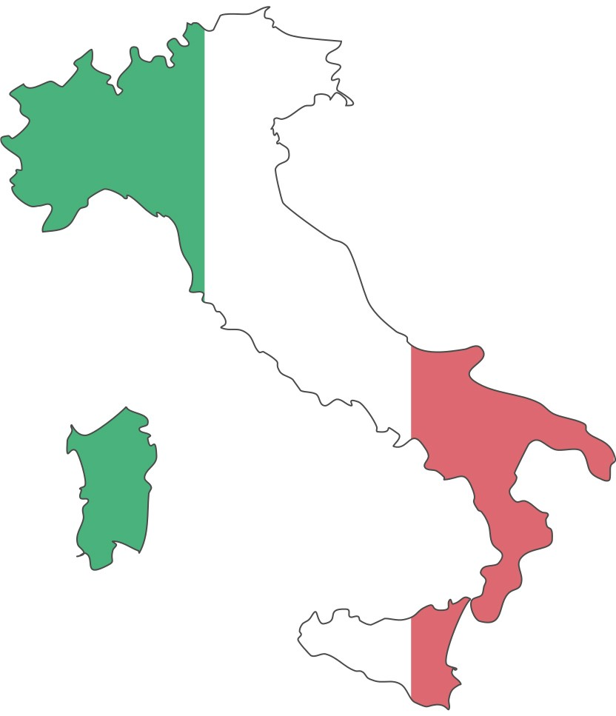
SUMMER IN MONTEPULCIANO, ITALY 2019
SESSION 1: May 16- June 20 • SESSION 2: June 27- August 1

9:00 – 9:30 Saturday, 27 April 2019 Check-in

9:30 – 11:30 General Orientation (Burrus Building, BB151, Kennesaw Campus, Kennesaw State University)

- Introductions: Directors, Faculty, and the Education Abroad Team and the Director of Global Operations (Joe Dirnberger and Todd Harper) 5 mins
- Online application, Education Abroad Policies and Forms (Katy Emslie)
Itinerary: Flights (Katy Emslie), 10 mins
Communication & Electronics: Phone, Internet, and Mail (Tara) 15 mins
- What to Bring: Weather, Packing, Guides/Maps, etc. and
Settling in and Cultural Immersion (Jim Winchester), 20 mins
- Weekend One, Classes, Field trips, (Joe Dirnberger) 15 mins
- What to Expect: Housing, Food, Money (Todd Harper), 15 mins
- Safety: Criminal, Social, Medical and Security, Weekend Travel, Insurance, On Call (Michael Sweazy), 25 mins
- Q&A 15 mins

11:30 – 1:00 Lunch Break (on your own)

1:00 – 2:00 Morning Classes Meet (both sessions)
(Syllabi will be distributed and course expectations discussed)

Location | Session I - AM | Professor
BB108 | Survey of Philosophy | James Winchester
BB114 | The Artistic and Cultural Heritage of Ancient Italy | Philip Kiernan
BB117 | World Civilizations to 1500 | Jayme Akers Feagin
BB109 | Gender and Society in Italy | Andrea Scapolo
Location | Session II – AM | Professor
BB372 | Plants and Civilization | Paula Jackson
BB380 | Introduction to Sociology | Christina Wolfe
BB381 | World Theatre - Greeks and Romans | Lisa L Abbott
BB384 | The Arts in Society | Dan Sachs

2:00 – 3:00 Afternoon Classes Meet (both sessions)
(Syllabi will be distributed and course expectations discussed)

Location | Session I - PM | Professor
BB108 | Love, Pleasure, Friendship and the Good Life | James Winchester
BB114 | The Arts in Society: Visual Art | Philip Kiernan
BB117 | Early Modern Europe: The Emergence of New Worldviews | Jayme Akers Feagin
BB109 | Introduction to Italian Language and Culture II | Andrea Scapolo
Location | Session II – PM | Professor
BB372 | Science Society and the Environment II | Paula Jackson
BB380 | Sociology of Food in Italy | Christina Wolfe
BB381 | Theatre Appreciation | Lisa L Abbott
BB384 | Donatello to Bernini | Dan Sachs

