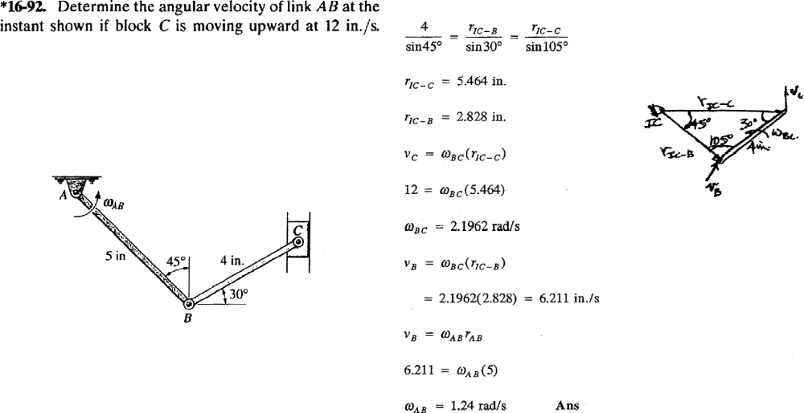
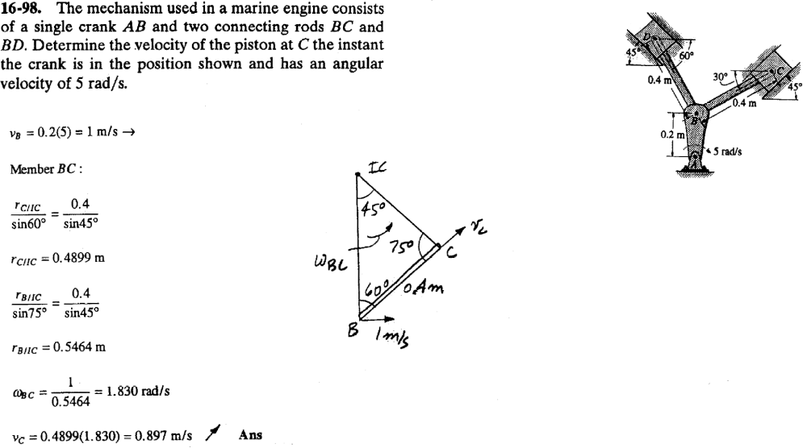
Notice that the velocity of C is along the slot which makes the angle of 45 degrees with the horizontal line, whereas the link BC makes the angle of 30 degrees with the horizontal line. However, the angles shown above are correct. Just the direction of Vc is shown incorrectly.
45
30


