Visual images test 4 Rococo-Post Imp

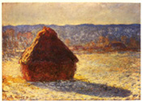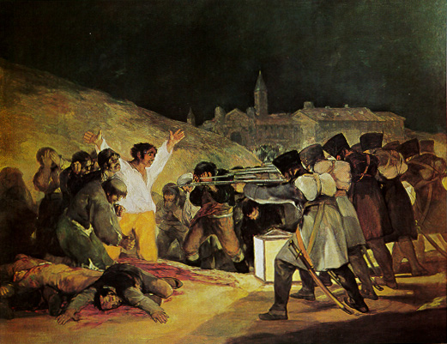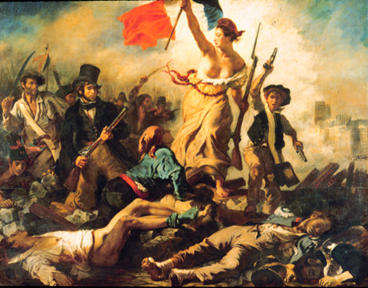

Monet, “Haystack” Goya, “The Third of May” Delacroix, “Liberty Leading
The People”, 1830

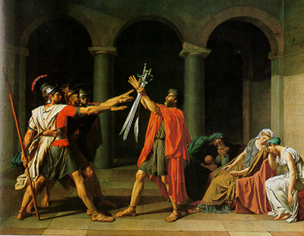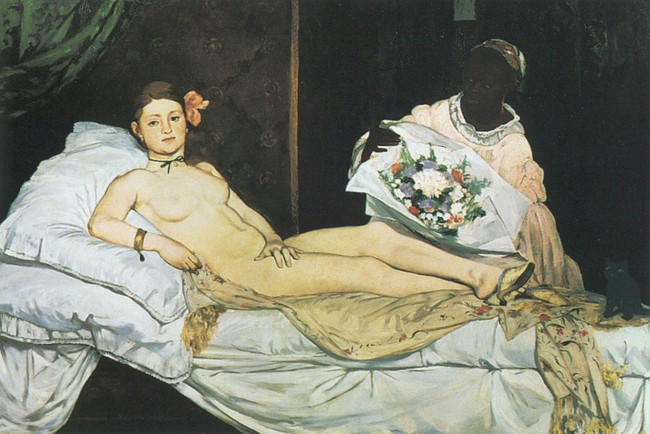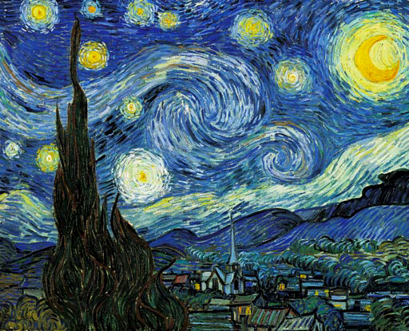

David, “the Oath of the Horatii”, 1784 Manet, “Olympia”,1863 vanGogh, “Starry Night”
1889
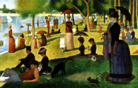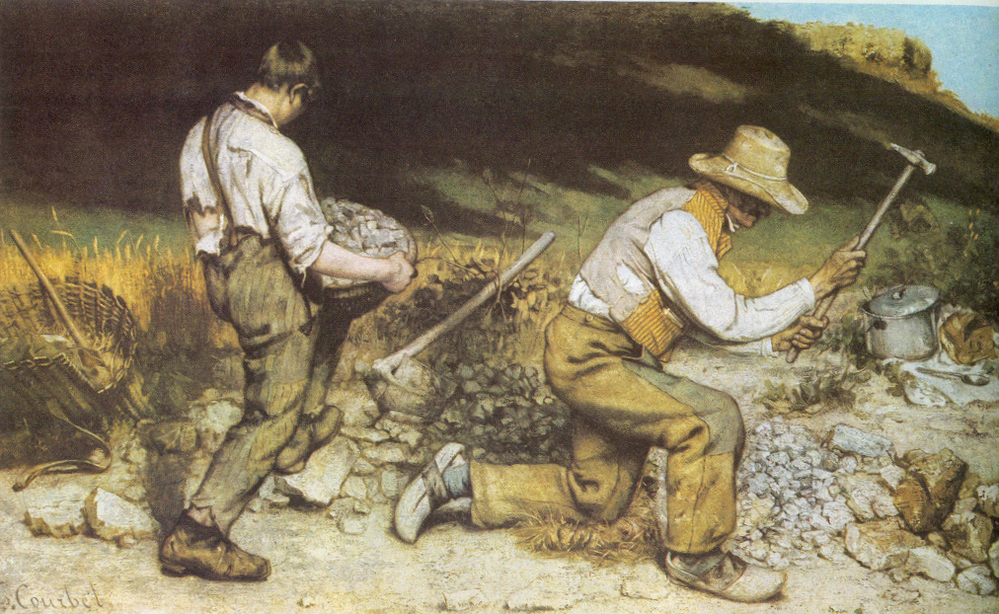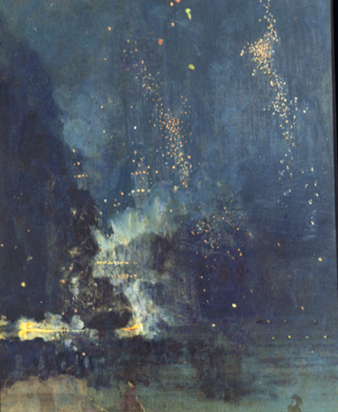

Seurat, “Sunday Afternoon on the Isle of Grande Jatte”, 1884-86 Whistler,
Middle- Courbet, “The Stone Breakers”,
End: Whistler, “Nocture in Black & Gold: the Falling Rocket”, 1875

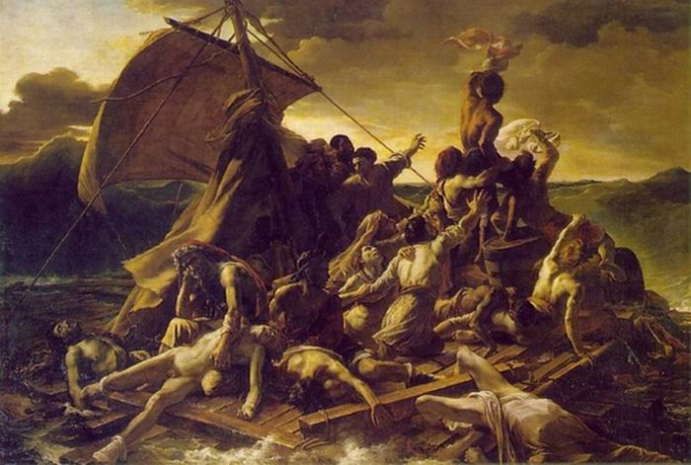
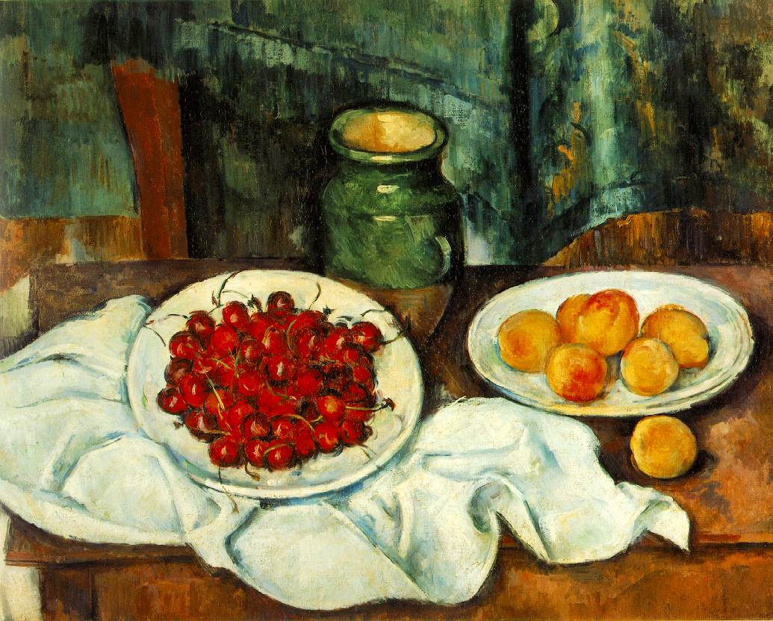
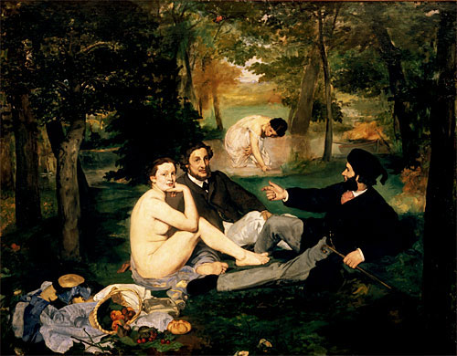

Manet, “Luncheon on the Grass”, 1863
Gericault, “the Raft of the Medusa”, 1818
Cezanne, “Still Life with Cherries”

