- Remember the object has an overall negative charge so the magnetic field is the opposite of what you think it is.
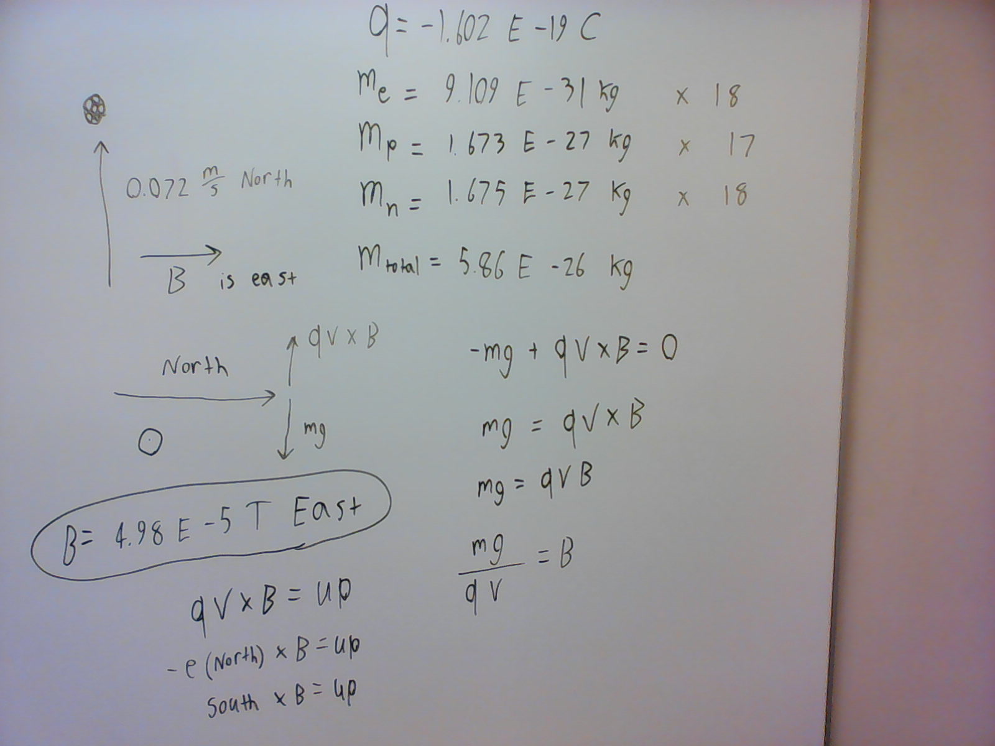
2.
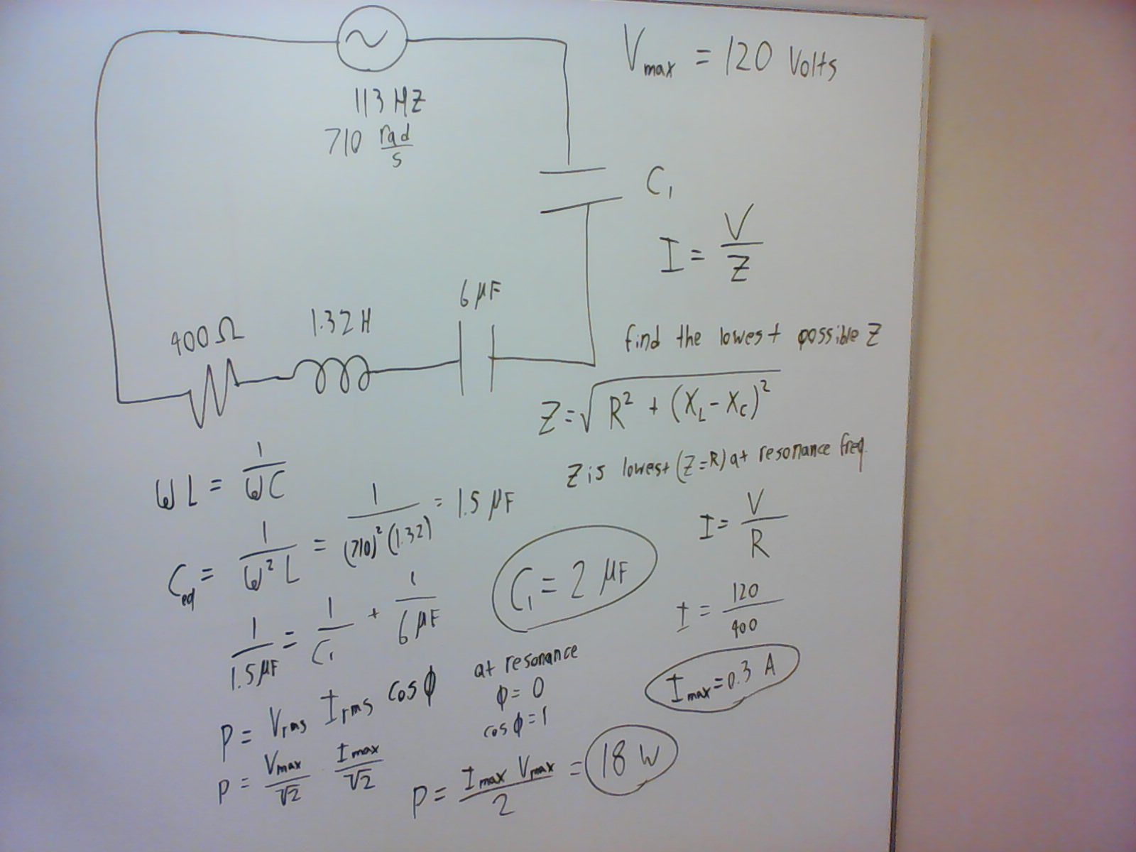
3. 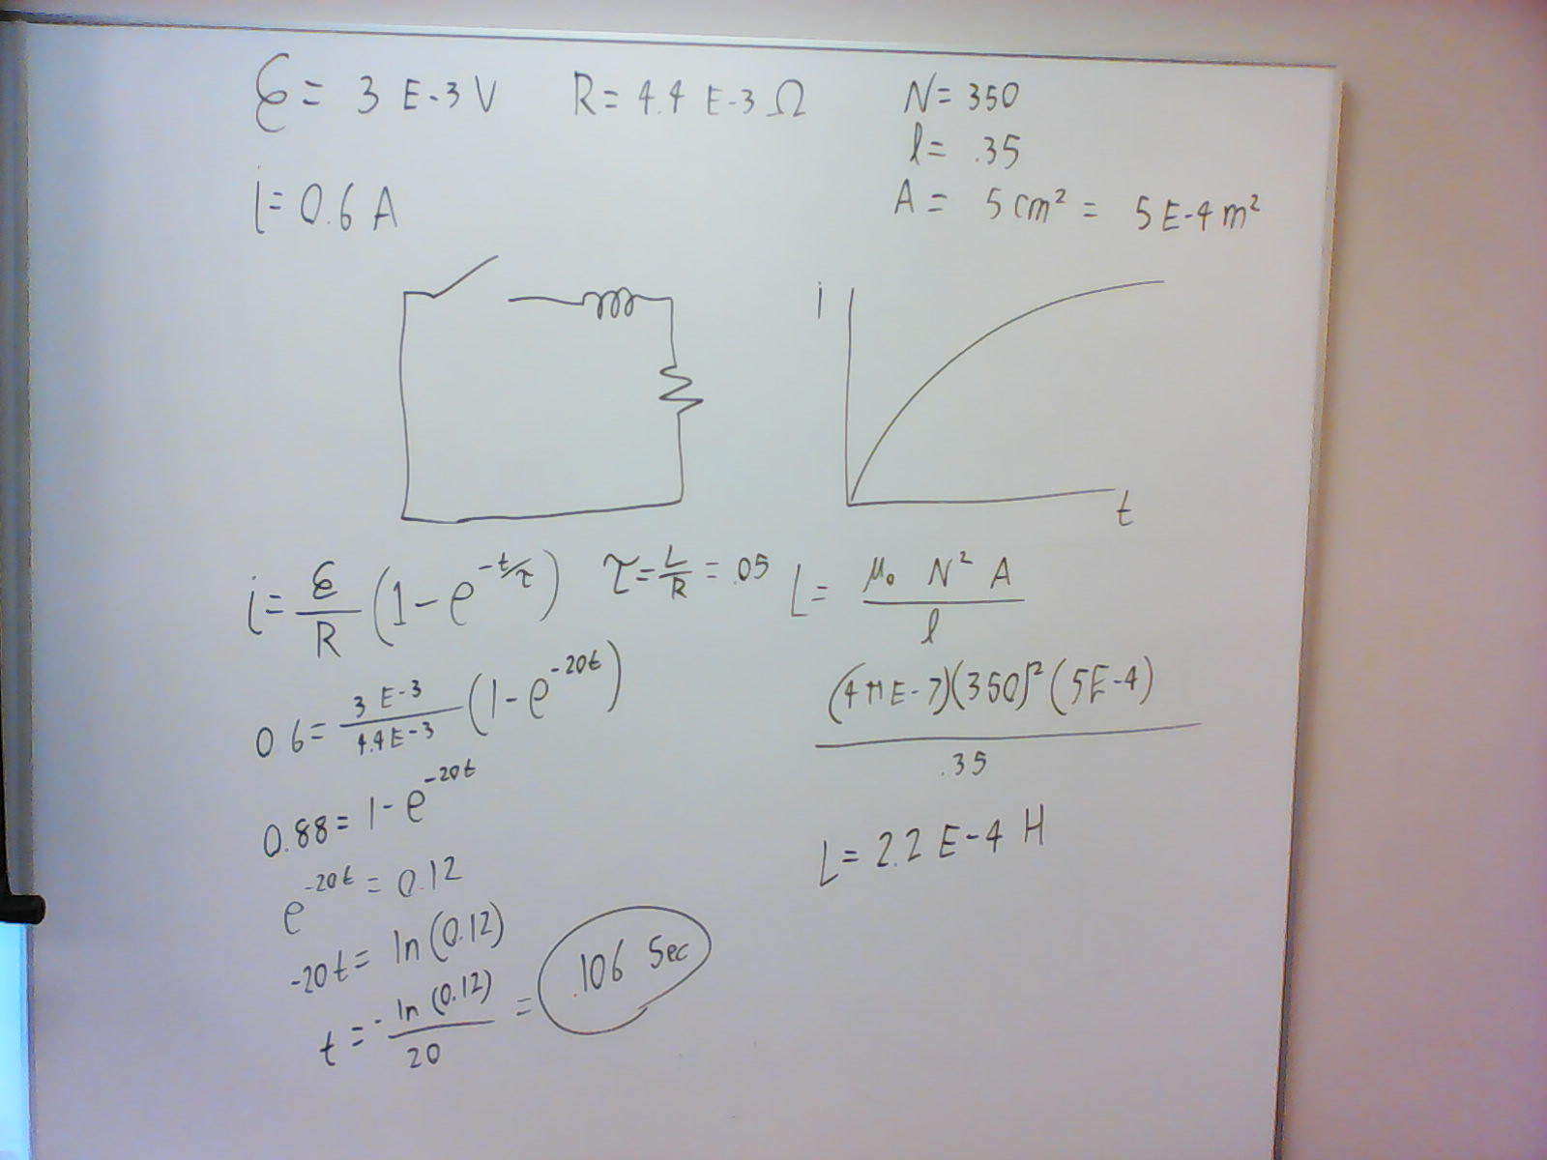
4. 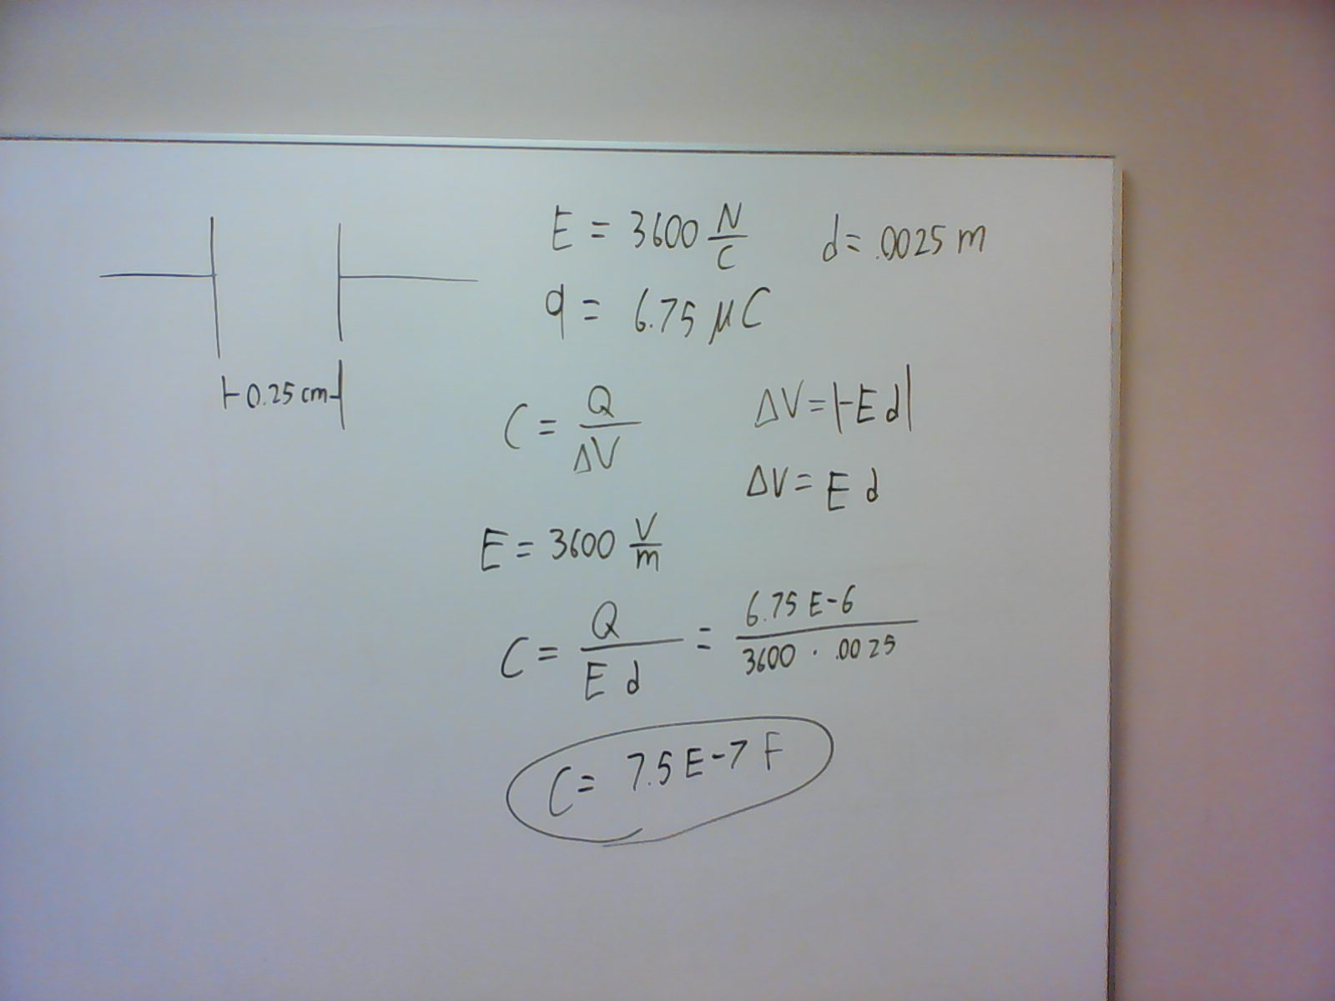
5. The answer should be 3.25 * 10 ^-8 T. I tried to put a circle on top of the photo but it may not be showing up.
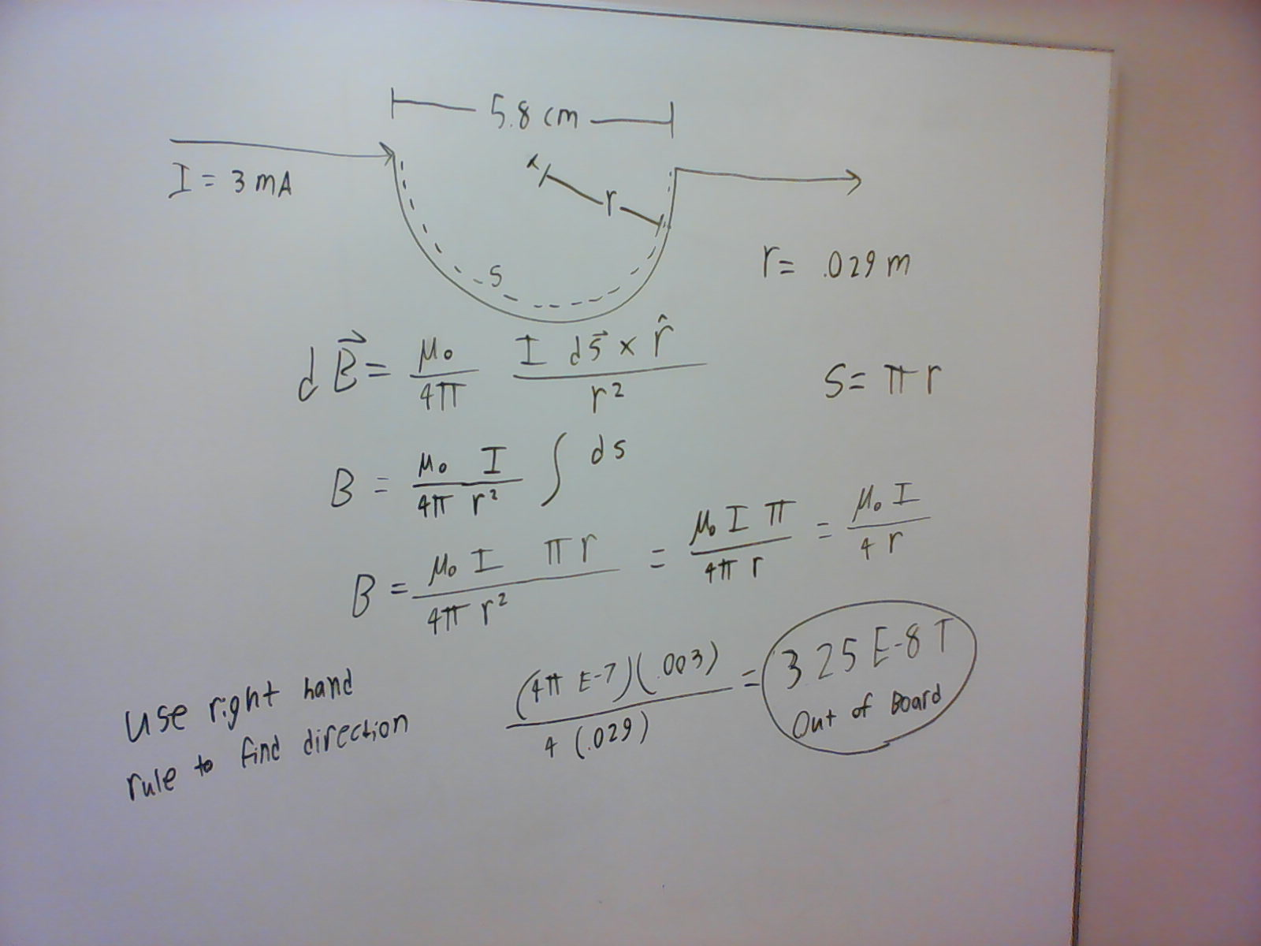
6. 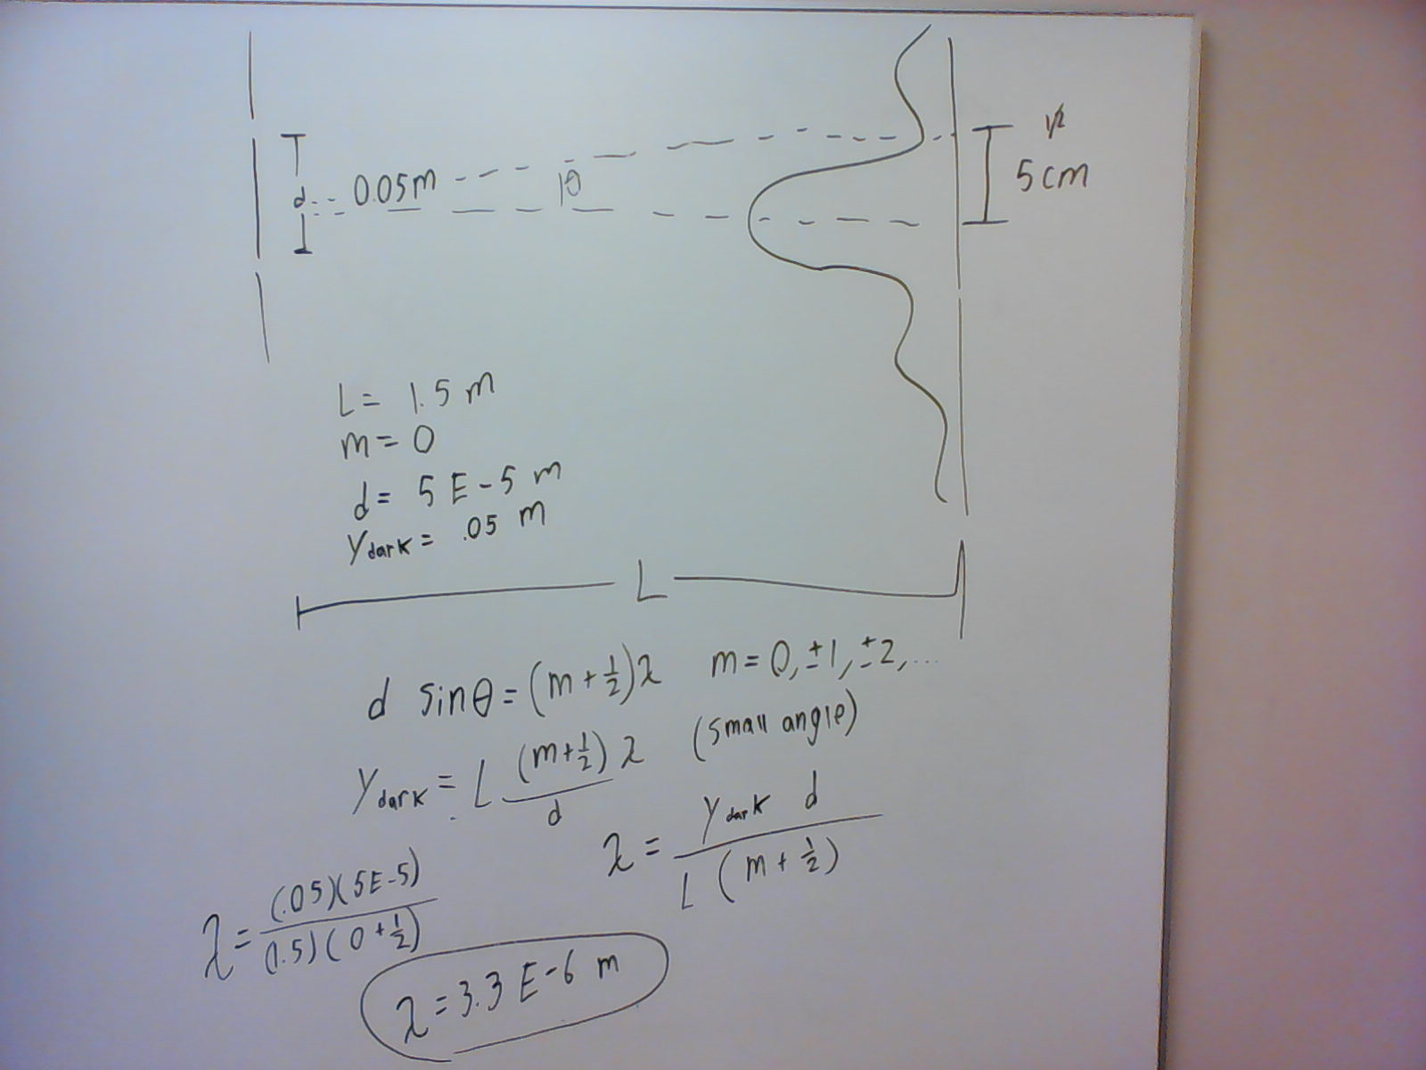

7. Note: the answer should be in radians.