coursera.org

AUGUST 07, 2014

Statement of Accomplishment

WITH DISTINCTION

D AVID JOFFE

HAS SUCCESSFULLY COMPLETED THE JOHNS HOPKINS UNIVERSITY'S OFFERING OF

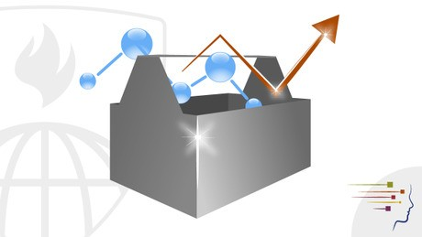The Data Scientist’s Toolbox Overview of the data, questions, & tools that data analysts & scientists work with. It is a conceptual introduction to the ideas
behind turning data into knowledge as well as a practical
introduction to tools like version control, markdown, git, GitHub, R, and RStudio.

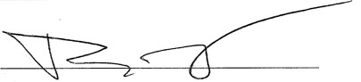JEFFREY LEEK, PHD
DEPARTMENT OF BIOSTATISTICS, JOHNS HOPKINS BLOOMBERG SCHOOL OF PUBLIC HEALTH
ROGER D. PENG, PHD
DEPARTMENT OF BIOSTATISTICS, JOHNS HOPKINS BLOOMBERG SCHOOL OF PUBLIC HEALTH

BRIAN CAFFO, PHD, MS
DEPARTMENT OF BIOSTATISTICS, JOHNS HOPKINS BLOOMBERG SCHOOL OF PUBLIC HEALTH

PLEASE NOTE: THE ONLINE OFFERING OF THIS CLASS DOES NOT REFLECT THE ENTIRE CURRICULUM OFFERED TO STUDENTS ENROLLED AT THE JOHNS HOPKINS UNIVERSITY. THIS STATEMENT DOES NOT AFFIRM THAT THIS STUDENT WAS ENROLLED AS A STUDENT AT THE JOHNS HOPKINS UNIVERSITY IN ANY WAY. IT DOES NOT CONFER A JOHNS HOPKINS UNIVERSITY GRADE; IT DOES NOT CONFER JOHNS HOPKINS UNIVERSITY CREDIT; IT DOES NOT CONFER A JOHNS HOPKINS UNIVERSITY DEGREE; AND IT DOES NOT VERIFY THE IDENTITY OF THE STUDENT.

