Directions to the freshwater marsh on Lake Acworth
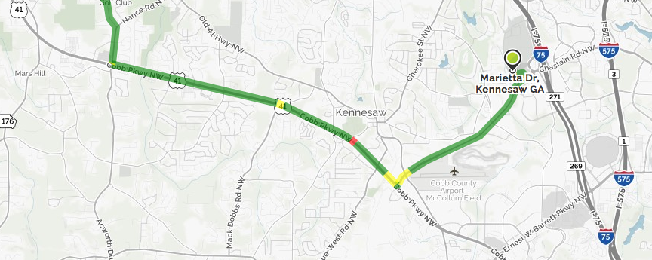
• Go right onto Chastain Rd NW. Chastain Rd NW becomes McCollum Pkwy NW.
• After ~ 2 miles, turn right onto Cobb Pkwy NW/US-41. Then 4.16 miles
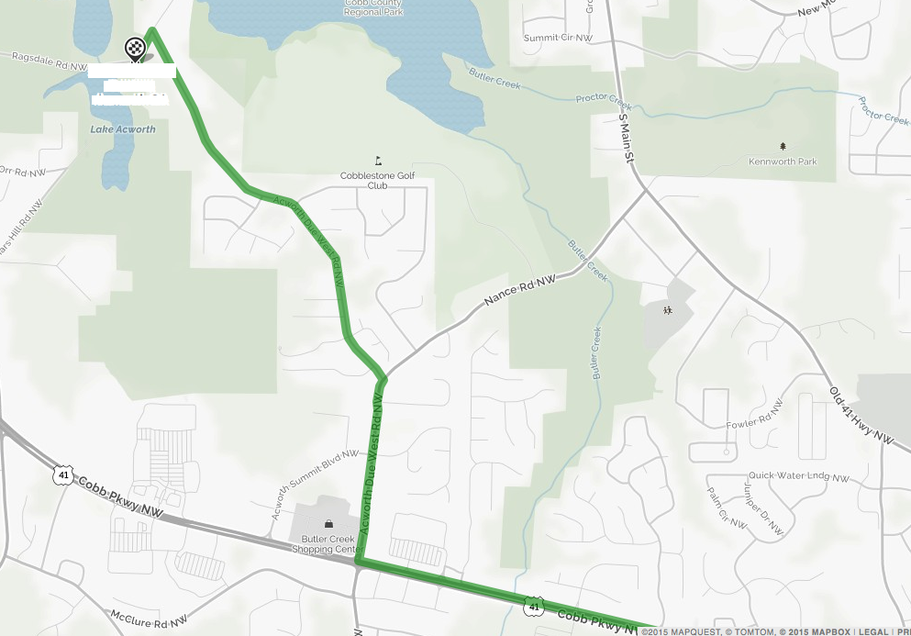
• Turn right onto Acworth Due West Rd NW at the signal past the Lowes.
• Then 0.49 miles, turn left to stay on Acworth Due West Rd NW (Acworth Due West becomes Nance at this point, so you have to make this left to continue on Acworth Due West)

• Then 1.17 miles, and turn left onto Ragsdale Rd NW. In <0.1 miles, there is a gravel shoulder large enough to park on the left side of the road where the road bends sharply to the right.

