Study Guide for Freshwater Ecology Exam #3

Overall
Explain how differences in the landscape result in the presence of wetlands, streams, and lakes.
Be able to answer the italicized questions in the lecture outlines
Recognize the general ideas in the reading Leopold 1966
Define the following terms
- wetland
- marsh
- swamp
- lacunae
- adventitious roots
- current velocity
- discharge
- load
- hyporheic zone
- riffle and pool

Wetlands
Know the criteria by which wetlands are delineated.
Explain how water movement is different in marine versus freshwater wetlands.
Know adaptations for plants to be able to live in wetlands
Describe the path of nutrients and energy through wetland ecosystems.
Describe the benefits of wetlands and how for each benefit wetlands provide these services.
Briefly describe how government policy has changed toward wetlands over the last couple of centuries.
Name human impacts to the landscape that have impaired the ability of the landscape to “purify” water. Be able to explain how these alterations affect water quality.

Physical and Chemical Stream Ecology
Understand the difference between current velocity and discharge.
Know the trends in the following diagram and be able to discuss reasons for these trends.
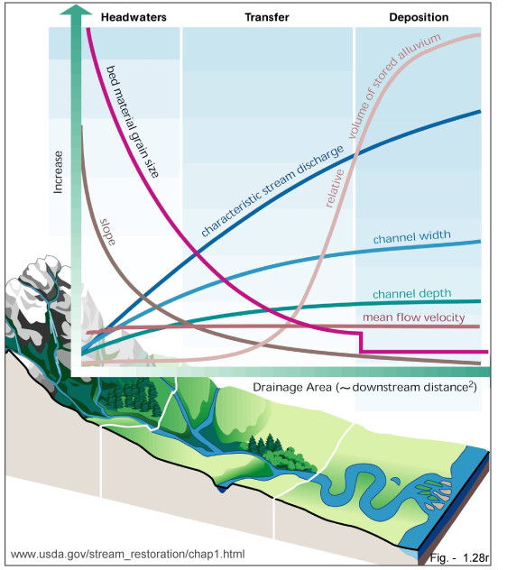
Describe subsurface flows beneath and into streams, and be able to discuss how this affects the quality of water and rate of flow.
Describe factors that affect whether particles in a stream are transported or deposited.
Describe the morphometry of typical stream and in terms of meanders how and why these changes through time.
Define “load” and explain how load for a given substance may change during a rain event. Understand why water and the substances it carries change over time in the hydrographs below, and how these patterns might change when wetlands upstream are destroyed or impervious surfaces are constructed in the watershed, and the environmental consequences of these actions.
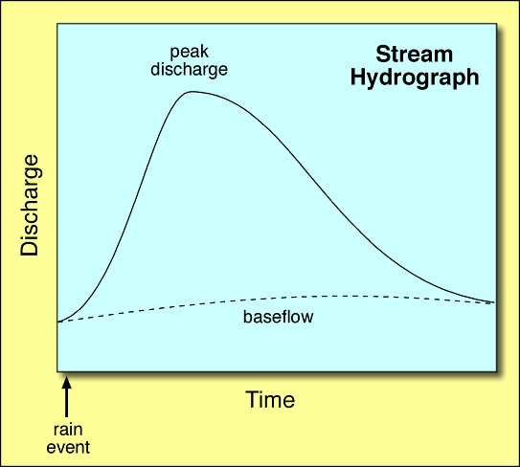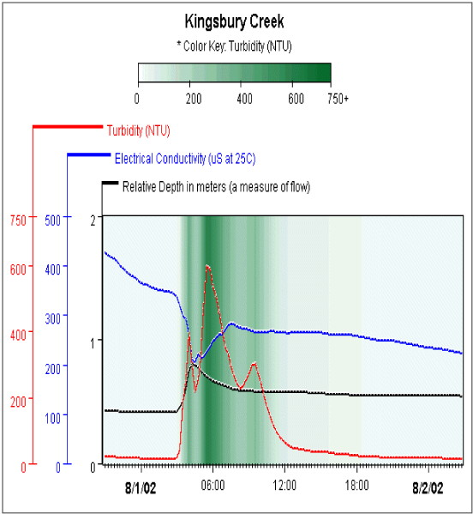

Understand the concept of nutrient spiraling and the factors that affect the length of the nutrient spiral.

