Exploring Montepulciano Activity

To help you get to know the town of Montepulciano a little better, please spend a little time on Saturday afternoon or Sunday visiting and investigating two businesses. Do this with your roommates in groups of 2 or 3 (i.e. each group visits 2 businesses). At least one of the businesses should be a shop, the other can be a restaurant, or a shop, or maybe something that is not even a business.

There are all kinds of interesting shops in the town including a cool leather shop, a bicycle rental business, an antique bookstore, a chocolate store, gelato stands, clothing shops, art galleries (including a guy who makes mosaics in his shop), a place that sells handmade notebooks and another that sells cooper goods, and numerous shops that sell gourmet food, locally produced wines, and locally grown vegetables and fruits. Many shops and restaurants are located along the Corso, the street on which the Trattoria is located.

You will report back on what they sell and what you found interesting among their merchandise. If possible, spend a few moments talking to an employee or owner of the business. Most shop personnel speak at least some English, and for those who speak less, do not be timid about attempting a conversation.

Introduce yourselves as college students living here for the next five weeks and studying at the Fortezza. Ask a few questions, such as:
- How long has the shop been there?
- Do they know anything about the history of the building that their business resides in?
- Do they have any recommendations concerning the products they sell?
- Or anything else you are interested in knowing.

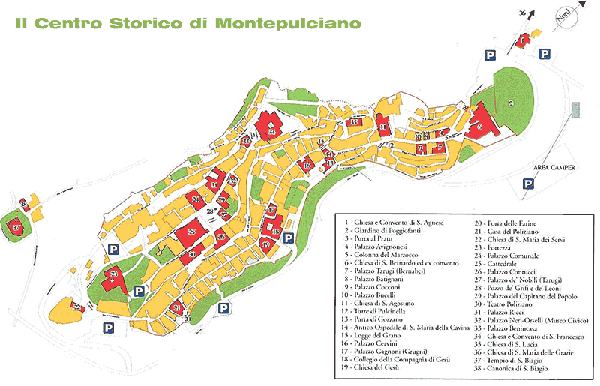
We will meet at the Fortezza at 5:30 PM on Sunday night to report to each other our findings.

