Summer in Montepulciano, Italy 2019

This Handout and more information can be found at the Montepulciano Summer Student Resource page at:
http://facultyweb.kennesaw.edu/jdirnber/montepulciano/montepulciano%20student%20resources.php

Money: We suggest waiting until you reach Italy to acquire Euros. If you wish to have Euros in your pocket before arrival, contact your local bank branch for instructions on purchasing Euros. There are money exchange facilities at Hartsfield, but their exchange rates are not favorable.

In Italy, you may get cash in Euros from ATMs (called bancomats) directly from your own checking account in the U.S. This will be the best exchange rate of all. Warning: Italian teller machines are sometimes out of service just as they are in the U.S. and repeated withdrawals of small amounts will total large fees from your bank. It is advisable to withdraw the largest amount possible each time you use the ATM. This is usually limited to 200-500 euros. Do NOT bring large sums of U.S. currency to exchange, as accessing your funds using ATMs will typically yield a much more favorable exchange rates (and be much easier to accomplish) than converting U.S. cash to euros.

Do NOT bring travelers checks. They are nearly impossible to use in Europe.

How much money do you need?
$800 – $1000 – you eat like a student and go on one or two weekend trips.
$1500 – you eat better, have more gelato, travel most weekends, and some shopping
$2000+ - plenty of money to shop, travel, and live La Dolce Vita!

Credit Cards: Major credit cards (Visa or MasterCard) are accepted for large purchases and in most restaurants. American Express is not as widely accepted. Look for the posted logo stickers or ask what cards are taken. Generally, restaurants will display accepted cards in their front window. Ask your bank/card company to send you a “chip” card if you do not have one.

Before departure, check with your bank and credit card providers to clear your cards for international usage and for all fee information concerning purchases and ATM withdrawals (you may want to apply for a “travel” card that has lower fees). If you do not alert your service provider, your account may be locked when unexpected charges begin to roll in from Europe. They will suspect that someone has stolen your card or numbers. Rectifying the situation can take as much as 72 hours. We suggest bringing at least two cards (credit/debit) in case one is locked/lost/stolen.

Prescription medicines: Be sure to bring them with the original prescription label. You should also bring a copy of the prescription(s) and a doctor’s note confirming you require the medication, especially for narcotic based medication. Do not count on having someone send prescription drugs from home: they may be confiscated by European customs or subject to heavy tariffs of several hundred dollars due on delivery. Be sure to pack all medications in your carry-on bag and not your checked luggage. Certain prescriptions cannot be filled by Italian pharmacies (psychotropic Schedule II and Schedule III drugs), so if you are on these types of prescriptions, be sure you bring with you a 6-week supply (you will likely have to ask your doctor for a “vacation” prescription that you fill before you go abroad).

Electricity/Appliances: Electrical current is 220 volts in Italy. Hairdryers and other appliances need to be dual voltage or else you will need a converter. Appliances that heat up (like flat irons and hairdryers) often do not fare well, even with a converter, and they have been known to start fires or blow fuses. Do not leave these appliances unattended when plugged in, or better yet, try to get along without them! Dual voltage appliances generally work better than converters, but your best option is to purchase appliances in Italy. They cost about the same as in the states. You will also need several adapter plugs as Italian outlets are different from those in the U.S. Please note: Converters and Adapters are NOT the same thing. Adaptors allow American plugs to plug into European plugs points. Computers and cell phones usually can convert 220-110

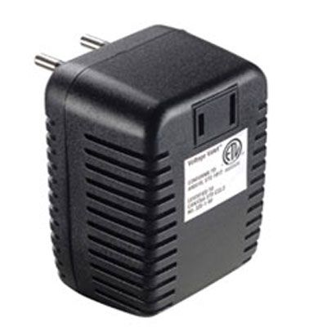
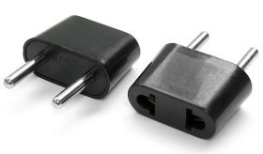
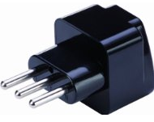

Converter Adapter Grounded Adapter

Clothing: Shorts and bare shoulders are not permitted in most Italian churches. Though we may think of them principally as examples of art and architecture, they are still places of worship, and Italians expect visitors to dress appropriately. Bring a wrap of some sort to cover any offending body parts.

Footwear: We will be walking a lot. Bring good footwear with treads on the soles. Be sure you have broken in you footwear before the trip. If you are not accustomed to walking, you should begin to get in shape for it. Sore muscles take the fun out of sightseeing (I mean scholarly pursuits). Montepulciano is a hilltop town: consider some Stairmaster training to build the leg muscles. Consider bring Moleskin to protect against blisters and Gold Bond powder to protect against chafing.

Toiletries: Many American brands of soap, shampoo, etc. will be available at the local supermarket, so you may want to bring only small sizes (if any) of these to save weight in your luggage. Montepulciano is a small town, however, so plan to bring enough of your favorite brand if you have allergies or absolutely cannot accept a substitute.

Guidebooks & Maps: Citymaps2go

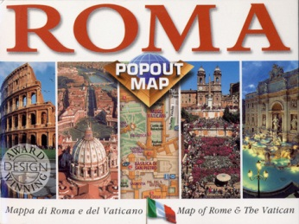
In the computer age, we recommend you do not buy a guidebook. If you want a guide, picking up an English guide is easy and cheap in any Italian city. A good map in much more important than a guidebook. Consider using the quick reference “popout” maps or a phone app.

Courtesy: Italians, in general, are friendly and easy to communicate with even when there is a language barrier. Remembering to “per favore” (please) and “grazie” (thank you) helps smooth the way.

COMMUNICATION
Email, Snail Mail, Skype, etc.:

The best form of communication with friends and family is email, skype, magic jack, and facetime. Internet connections are available in Montepulciano at limited locations (including our classroom building, the Fortezza), and in internet cafes across Italy and Europe.

Family/friends may write or send packages to you via AIRMAIL at the following address:

(Your Name)
Georgia Study Abroad Program
Cooperativa “Il Sasso”
Via di Gracciano nel Corso, 2
53045 Montepulciano (SI)
Italy

Packages from home that include food (cookies that mom has baked), technology (a replacement cell phone) and prescriptions/cosmetics (your acne medications or psychotrophic scripts) cannot be received. These things will likely be confiscated or held until a customs duty is paid.
For sending postcards and letters home, stamps may be purchased at the Post Office or any tobacco shop (marked by a black sign with a white “T”). Remember that addresses on mail sent home must include “USA” or “United States”.

Telephone Communication:

There is no telephone service in the apartments. To make international calls, either:

- Rent an international cell phone. There is a phone store in Montepulciano that is VERY familiar with our students’ needs. You may also explore internet options for more options and services. The benefit of an Italian phone number is, in Italy, only the caller is charged for calls. Avoid huge bills by having your family and friends call you back.

- Activate your cell phone for international use. (Please contact your carrier to determine if your phone and phone plan will work in Italy and any other country you may be planning on visiting and all rates/fees). This is a very expensive option!

Let your family and friends know that cell service can be difficult inside the thick walls of the apartments. Tell them to leave a message and you will get back to them when you can. Try to avoid constant contact with home. You are in Italy, ENJOY!!!

- If your family needs to contact you in an emergency (and only in an emergency), they may call the Site Director, Ken Hill (1.770.940.7549 or +39.331.438.2177; khill@kennesaw.edu ) or the Academic Director Session I: Joe Dirnberger (+39.392.763.4563 or 1.770.490.0034; jdirnber@kennesaw.edu ), Academic Director Session II: Todd Harper (+39.392.763.4563 or 1.770.367.8688; tharper@kennesaw.edu)
or leave a message with the:
Scula di Italiano il Sasso: 001-39 0578 758311
(The office at il Sasso will generally close at 1:00 p.m. Georgia time.)

If your family has trouble getting through, they may contact Katy Emslie (470.578.4953; kemslie@kennesaw.edu) or Iyonka Strawn-Valcy (470-578-7787; istrawnv@kennesaw.edu ) at the Education Abroad Office (Main office#: 470-578-6336), and they will contact you as soon as possible.

While in Montepulciano, contact Ken Hill or the Academic Director (at the phone numbers listed above) in case of emergency, before calling the local police (112). The number for general emergencies is 113 and for fire it is 115.

Be Flexible:

You are going abroad for the experience of a different culture. Do not expect Italy to be like the U.S. The pace of life in general is slower. Meals are a major event in life and therefore take a long time. Service in restaurants will be slower paced. Most shops and some tourist attractions are closed between lunch and 3:00 p.m.

In spite of all the tourists, Italy isn’t Disney World. These are living, functioning cities with all the noise, traffic, and dirt that come along with a city. There will be grit, grime and graffiti along with all the marble and masterpieces. That said, Italy is a safe country. What may be seen as signs of high crime areas in the US (such as graffiti) rarely represent the same in Italy.

There will be inevitable delays with both air and ground transport. We have nominated “Our Lady of Perpetual Waiting” as an addition to the collection of recognized Italian saints. Bring along something to read.

Be Careful:

While Italy is a friendly place, remember you will be in big cities and major tourist centers when we are on field trips. These attract petty criminals. Do not bring expensive jewelry. Do not carry your passport with you unless absolutely necessary. Always be aware of your camera and your purse. Purse snatching is an opportunistic crime. It is generally recommended that you carry a small purse with the strap diagonally across your body, making it a less tempting target. Money belts are NOT recommended. Nothing says “I’m a tourist carrying lots of money” than rooting around under layers of clothes for cash. Travel with at least one buddy and watch out for each other. When stopping to look at a map, guidebook, or your phone, stand out of the way and with your back against a wall. Always keep bags and luggage IN FRONT of you when standing still (on public transport, ticket machine, ATM, etc.).

THINK SAFETY! We do not want anyone hurt. Not only is this a bad thing in of itself, but also, any disruption due to injury could result in postponement or cancellation of activities. Ask yourself, “would I do this in the U.S.?” If not, don’t do it in Italy.

