Before the Paragraph, After the Prompt: Collaborative Invention with Generative AI

Why This Matters
Effective writing doesn’t begin with the first sentence; it begins with clear decisions about purpose, audience, genre, tone, and style and with mindful checks for usefulness, relevance, accuracy, and harmlessness. In this assignment you will practice both, infusing your process with generative AI and using two models to guide you.

Frameworks You Will Need (Also Available as Separate Files)
These frameworks were developed and tested with students like you, who want to use generative AI effectively and responsibly. The Rhetorical Prompting Method (RPM) might look familiar to you, because it is a “riff” on the writing process you already know!
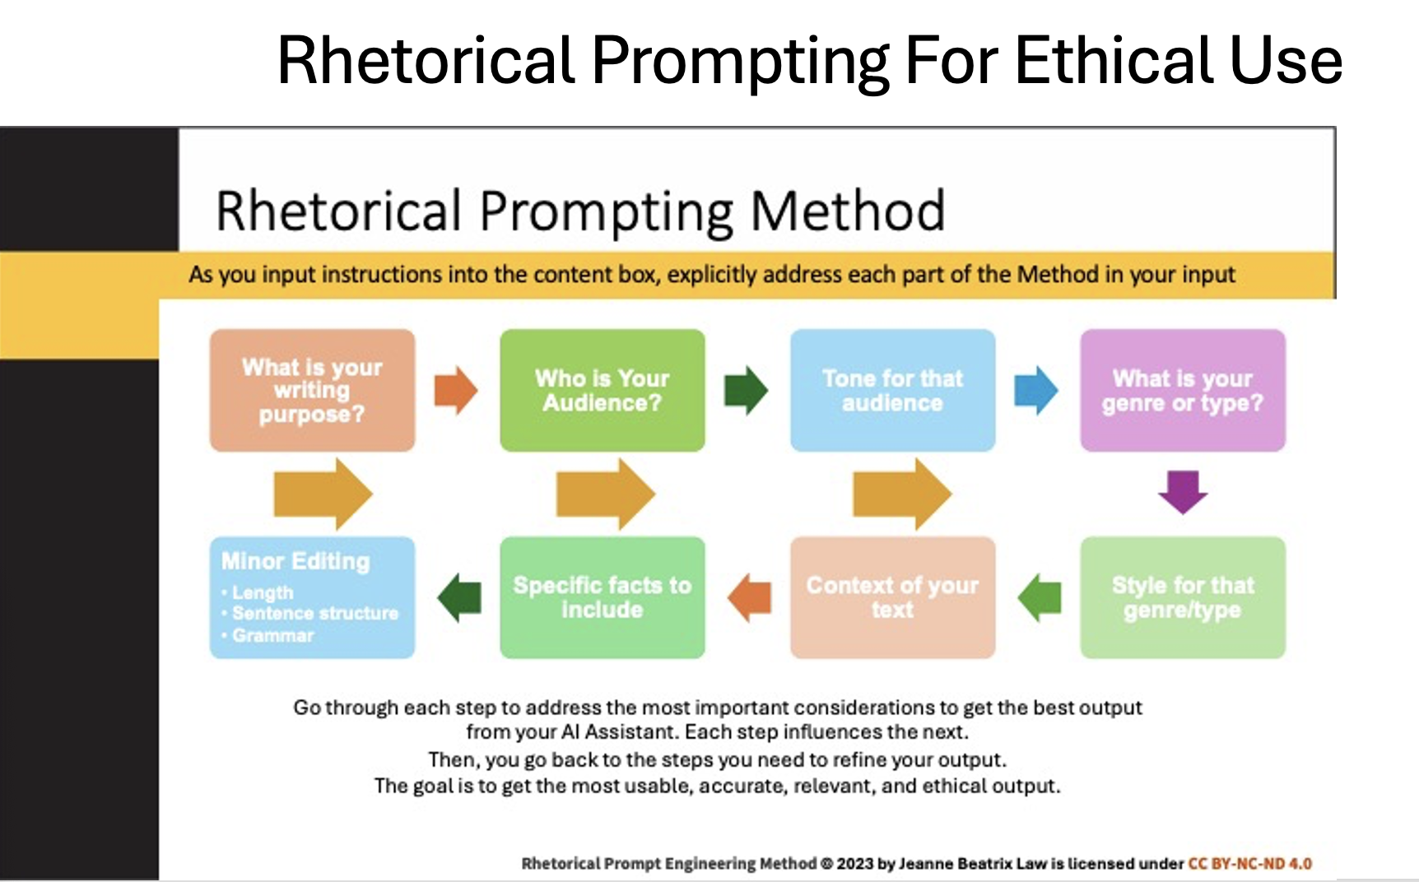

The second model, the Ethical Wheel of Prompting (EWP) helps you make sure you remain in control of your voice and ideas when you use generative AI. Ask yourself the four questions going through the Wheel, knowing that it’s OK to return to previous steps in your prompting process if you aren’t sure that the outputs meet your needs or your vision. Knowing when an output just doesn’t “pass the smell test” is part of being an effective writer!

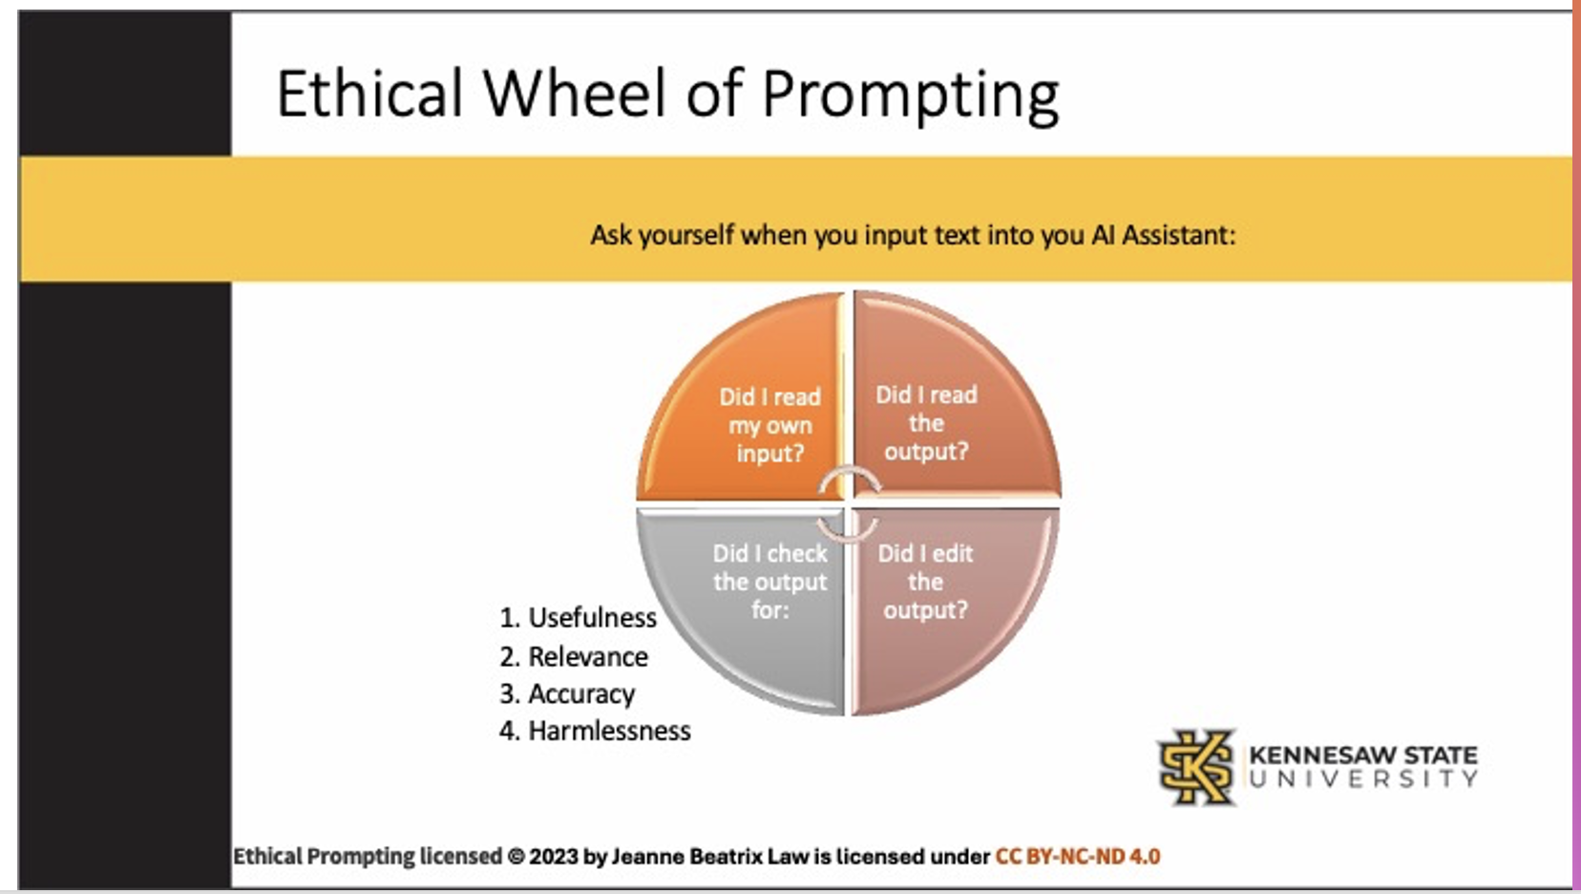

Assignment Task 1 – Creating a Rhetorical Prompt Portfolio (Using Rhetorical Prompting Method-RPM)
You want to be able to precisely design and refine prompts that are purpose‑built, audience‑aware, and genre‑specific.
1. Choose a topic or idea you want to explore (option: instructor provides)
2. Set the Stage (RPM Steps 1‑4) – Decide writing purpose, audience, tone, genre.
3. Refine the Request (RPM Steps 5‑7) – Specify style, context, must‑include facts.
4. Quick Polish (RPM Step 8) – Scan output for length, sentence structure, grammar.
5. Annotate each transcript – identify RPM step used and one choice driven by EWP.

Template starter prompt:
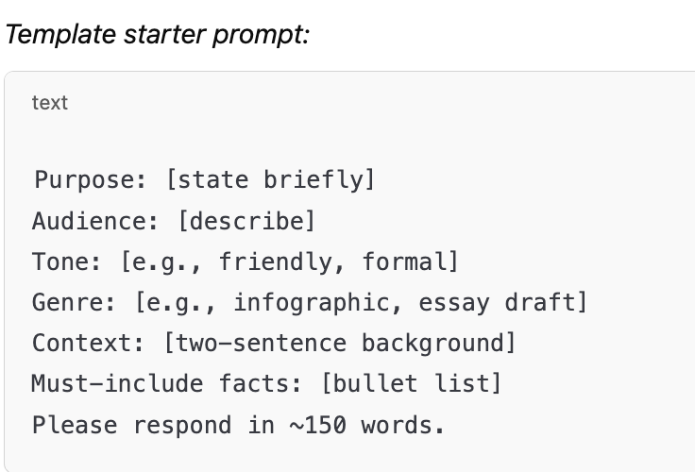

Example Using student-chosen topic:
For each of the following parts of the Rhetorical Prompting Method, you will type your own ideas and words into your AI’s chat-box. It might look something like this, with italics representing what you type in the box:
Purpose: Please draft notes for of a Rogerian op-ed persuading the Georgia House Public Safety Committee to reconsider policing practices affecting undocumented college students.
Audience: Committee members and general public readers of the Atlanta Journal-Constitution.
Tone: Constructive, empathetic, solutions-oriented.
Genre: 250-word op-ed written to legislator but with general newspaper audience in mind first.
Style: Plain-language, 12th-grade readability; incorporate one rhetorical question.
Context: Connect the 1960 Appeal for Human Rights grievances with 2025 concerns about campus policing.
Facts: Quote the grievance on “police intimidation,” include GA HB 1234 campus-deportation data, and reference Roslyn Pope’s authorship.
Minor Editing: I’ll polish for clarity after you give me your draft.
**(EWP REMINDER: reread before sending my prompt before hitting the “ENTER” button**

Assignment Task 2 – Reflection (Using Ethical Wheel of Prompting-EWP)
You want to be able to ensure that your writing is yours, along with your ideas. By holding yourself and your generative AI accountable in the following ways, you make sure that you remain in control of the editing and use of the AI’s outputs.
Write ~300 words answering the four EWP questions:
1. Did I reread my prompt before sending it?
2. Did I read the AI’s response carefully?
3. Did I check that response for usefulness, relevance, and accuracy?
4. Did I edit the output for usefulness, relevance, accuracy, and harmlessness? (RPM Step 8.)
Reflections demonstrate that students are reading and evaluating inputs and outputs, getting closer to metacognition when they make rhetorical editing choices.

Assignment Task 3 – Annotate with a Concept Map or Outline
Show visually how your topic/idea moved from Prompt → AI Output → Your Edits. Label each arrow with the RPM step and EWP check you applied. Focus on your actions as the human in control of the AI process.
Beginnings of an Example Topic: An Appeal for Human Rights by Roslyn Pope (1960) is relevant in 2025 when we think about how law enforcement interacts with undocumented students on college campuses in Georgia.
My Actions | RPM Step | EWP Check | What Happened
Prompt ➜ AI | 5-7 | 2 | AI drafted information but hallucinated month & stat, shifted tone too much
AI ➜ Edits | 8 | 3-4 | I corrected factual errors, cited Pew Center research, softened tone to align with my intended audience

Deliverables and Timeline
Part | What You Produce | Framework Focus | Due
1 | Rhetorical Prompt Portfolio – 3 distinct AI prompts + annotated transcripts | RPM (steps 1‑8) | See LMS
2 | 300‑word Ethical Reflection | EWP (questions 1‑4) | See LMS
3 | Concept Map or Outline showing idea evolution | RPM ↔ EWP integration | See LMS

Assessment Rubric (abbreviated)
Criteria | High Complete | Low Complete | Incomplete
RPM Application | Prompts align with all steps; annotations insightful | Some steps missing or unclear | Minimal evidence of RPM
EWP Reflection | Thorough, honest; applies all 4 Qs | Addresses most Qs | Superficial or missing
Evolution Map | Detailed logical connections, clear revisions | Some connections unclear | Incomplete or missing
Professionalism | On-time, organized format | Minor formatting issues | Missing parts

Quick Reference Checklists (also see handouts)
RPM Mini‑Checklist:

- 1. Purpose
- 2. Audience
- 3. Tone
- 4. Genre
- 5. Style
- 6. Context
- 7. Facts
- 8. Minor Editing

EWP Mini‑Checklist:
- Read my input
- Read output
- Checked usefulness/relevance/accuracy (URAH)
- Edited for U/R/A/H

Rhetorical Prompting Method (RPM) Quick Reference Handout

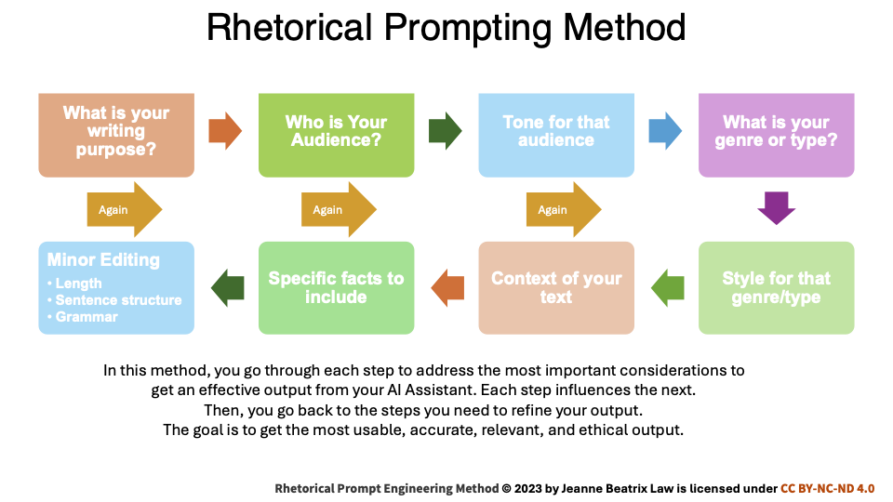
Eight‑step cycle:
1. Writing Purpose

2. Audience

3. Tone for Audience

4. Genre/Type

5. Style for Genre

6. Context of Text

7. Specific Facts to Include

8. Minor Editing (length, structure, grammar)
Iterate through the steps until the output meets your needs and aligns to your original rhetorical vision for your piece of writing.

Ethical Wheel of Prompting (EWP) Quick Reference Handout

Ask these four questions at every prompt‑response cycle:
1. Did I reread my prompt (input) before sending?

2. Did I read the AI’s output carefully?

3. Did I check the output for Usefulness, Relevance, Accuracy?

4. Did I edit the output for Usefulness, Relevance, Accuracy, Harmlessness?

