IT 6823 LM 10. Data Science in Security

Learning Material

Note: The learning material is composed of a list of web links, videos, and other materials screened and/or created by the instructor. The material is organized by student outcomes. Essential information is included in this document and students are recommended to go to the links to learn more about a specific topic.

Overview
The module gives an overview of application of data science in information security. The learning material is mainly based on the following survey paper which is provided in the D2L course website as a PDF file. The paper is referred as the Survey Paper in the rest of the document.
Sarker, Iqbal H., A. S. M. Kayes, Shahriar Badsha, Hamed Alqahtani, Paul Watters, and Alex Ng. “Cybersecurity Data Science: An Overview from Machine Learning Perspective.” Journal of Big Data 7, no. 1 (December 2020): 41. https://doi.org/10.1186/s40537-020-00318-5.

Student Learning Outcomes
- Describe data science in cybersecurity.
Page 2, 3, and 11 of the Survey Paper. Need to know terms and areas related to CDS (table 3).
Cybersecurity Data Science (CDS) is broadly related to these areas in terms of security data processing techniques and intelligent decision making in real-world applications. Overall, CDS is security data-focused, applies machine learning methods to quantify cyber risks, and ultimately seeks to optimize cybersecurity operations. The ultimate goal of cybersecurity data science is data-driven intelligent decision making from security data for smart cybersecurity solutions.

Term Popularity based on Google Trends

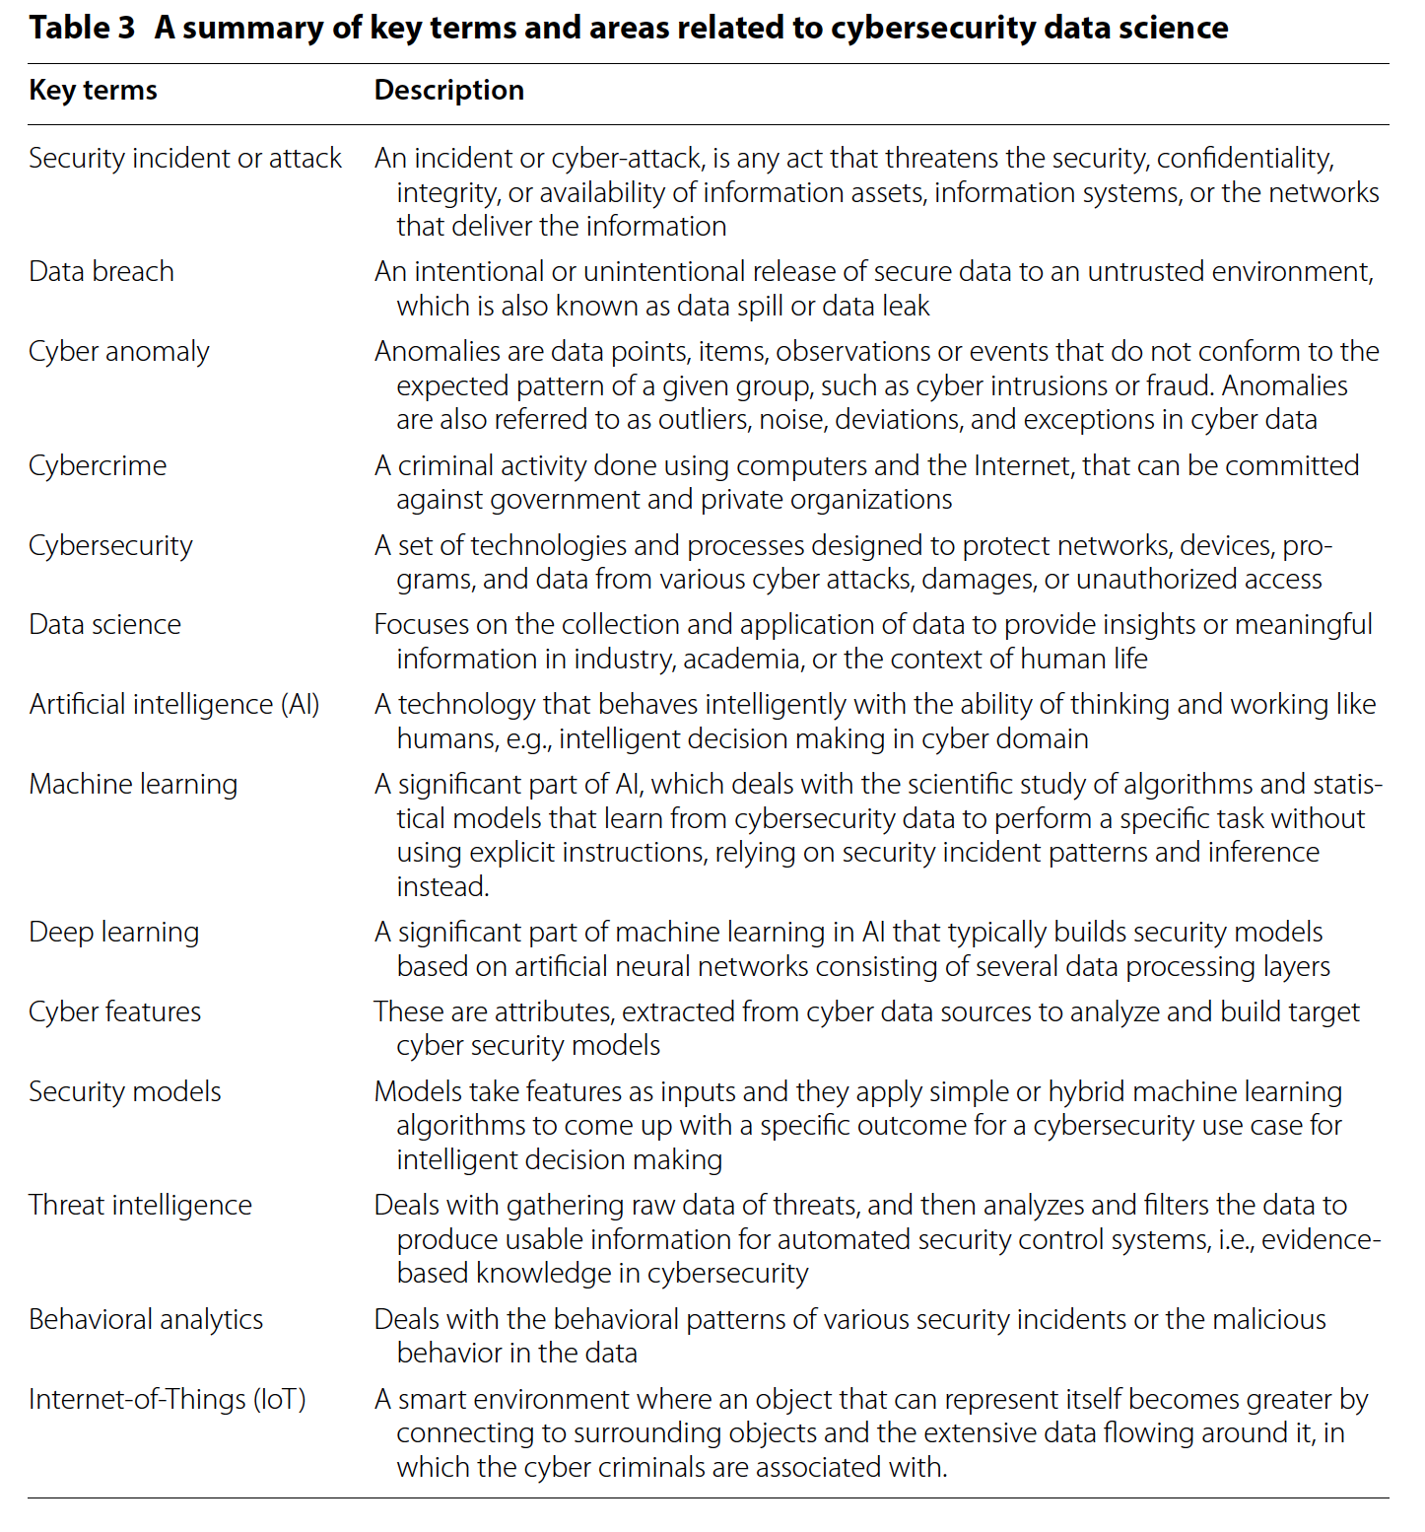
- Explain data science and data driven tasks in security
Page 8 and 9 of the Survey Paper.
Data science is a new interdisciplinary field that synthesizes and builds on statistics,
informatics, computing, communication, management, and sociology to study data
and its environments, to transform data to insights and decisions by following a data-to-
knowledge-to-wisdom thinking and methodology. Interdisciplinary field of data collection, preprocessing, inferring, or making decisions by analyzing the data.
Data-driven tasks in security i) data engineering focusing practical applications of
data gathering and analysis; (ii) reducing data volume that deals with filtering significant
and relevant data to further analysis; (iii) discovery and detection that focuses on
extracting insight or incident patterns or knowledge from data; (iv) automated models
that focus on building data-driven intelligent security model; (v) targeted security alerts
focusing on the generation of remarkable security alerts based on discovered knowledge that minimizes the false alerts, and (vi) resource optimization that deals with the available resources to achieve the target goals in a security system. While making data-driven decisions, behavioral analysis could also play a significant role in the domain of cybersecurity.

- Describe the machine learning tasks in cybersecurity
Page 12-14 of the Survey Paper. Need to know the basic concepts and example algorithms of each category.
Supervised learning is performed when specific targets are defined to reach from a certain set of inputs, i.e., task-driven approach. In the area of machine learning, the most popular supervised learning techniques are known as classification and regression methods.
In unsupervised learning problems, the main task is to find patterns, structures, or
knowledge in unlabeled data, i.e., data-driven approach. Clustering techniques, a
type of unsupervised learning, can help to uncover the hidden patterns and structures
from the datasets, to identify indicators of such sophisticated attacks.
Neural Network and Deep learning is a part of machine learning in the area of artificial intelligence, which is a computational model that is inspired by the biological neural networks in the human brain. Artificial Neural Network (ANN) is frequently used in deep learning and the most popular neural network algorithm is backpropagation [82]. It performs learning on a multi-layer feed-forward neural network consists of an input layer, one or more hidden layers, and an output layer. The main difference between deep learning and classical machine learning is its performance on the amount of security data increases. Typically deep learning algorithms perform well when the data volumes are large, whereas machine learning algorithms perform comparatively better on small datasets.
Other learning techniques - Semi-supervised learning can be described as a hybridization of supervised and unsupervised techniques discussed above, as it works on both the labeled and unlabeled data. Deep learning approaches mimic the human
brain mechanism to interpret large amount of data or the complex data such as images,
sounds and texts. In terms of feature extraction to build models, deep learning
reduces the effort of designing a feature extractor for each problem than the classical
machine learning techniques. Beside these characteristics, deep learning typically takes
a long time to train an algorithm than a machine learning algorithm, however, the test
time is exactly the opposite.
- Describe the multi-layer framework for smart cybersecurity services
Page 19-22 of the Survey Paper. Need to know the activities involved in each phase.

