IT 6823 LM 11. Mobile and Cloud Security

Learning Material

Note: The learning material is composed of a list of web links, videos, and other materials screened and/or created by the instructor. The material is organized by student outcomes. Essential information is included in this document and students are recommended to go to the links to learn more about a specific topic.

Overview
The module gives an overview of mobile and cloud security. The learning material is mainly based on the following 2 survey papers which are provided in the D2L course website as a PDF files.
- Survey paper 1 - Y. Zou, J. Zhu, X. Wang and L. Hanzo, "A Survey on Wireless Security: Technical Challenges, Recent Advances, and Future Trends," in Proceedings of the IEEE, vol. 104, no. 9, pp. 1727-1765, Sept. 2016, doi: 10.1109/JPROC.2016.2558521.
- Survey paper 2 - Tabrizchi, Hamed, and Marjan Kuchaki Rafsanjani. “A Survey on Security Challenges in Cloud Computing: Issues, Threats, and Solutions.” The Journal of Supercomputing 76, no. 12 (December 2020): 9493–9532. https://doi.org/10.1007/s11227-020-03213-1.

Student Learning Outcomes
- Describe the different types of wireless networks and their security requirements
Types of wireless network – source: https://www.computernetworkingnotes.com/ccna-study-guide/types-of-wireless-network-explained-with-standards.html
Type | Coverage | Performance | Standards | Applications
Wireless PAN | Within reach of a person | Moderate | Wireless PAN Within reach of a person Moderate Bluetooth, IEEE 802.15, and IrDa Cable replacement for peripherals | Cable replacement for peripherals
Wireless LAN | Within a building or campus | High | IEEE 802.11, Wi-Fi, and HiperLAN | Mobile extension of wired networks
Wireless MAN | Within a city | High | Proprietary, IEEE 802.16, and WIMAX | Fixed wireless between homes and businesses and the Internet
Wireless WAN | Worldwide | Low | CDPD and Cellular 2G, 2.5G, and 3G | Mobile access to the Internet from outdoor areas

Survey paper 1 – Section II
In principle, wireless networks should be as secure as wired networks. This implies that the security requirements of wireless networks should be the same as those of wired networks, including the requirements of authenticity, confidentiality, integrity, and availability. However, due to the broadcast nature of radio propagation, achieving these security requirements in wireless networks is more challenging than in wired networks. For example, the availability of wireless networks is extremely vulnerable, since jamming attack imposing a radio signal can readily disrupt and block the wireless physical-layer communications. Hence, compared to wired networks, wireless systems typically employ an additional DSSS (or FHSS) technique in order to protect the wireless transmissions against jamming attacks.
- Discuss the security vulnerabilities in wireless networks
Survey paper 1 – section III. Need to know 1) the relationship between the wired and wireless attacks; 2) main protocols and specifications of the wireless osi layers; 3) Major types of attacks at physical layer and MAC layer; 4) comparison between the wireless and wired networks in terms of security attacks at different OSI layers.
- Describe the open challenges in wireless security
Survey paper 1 – Section VIII. Briefly discuss the challenges in wireless network security.
- Discuss basic concepts in cloud computing
Survey paper 2 – section 1 Introduction
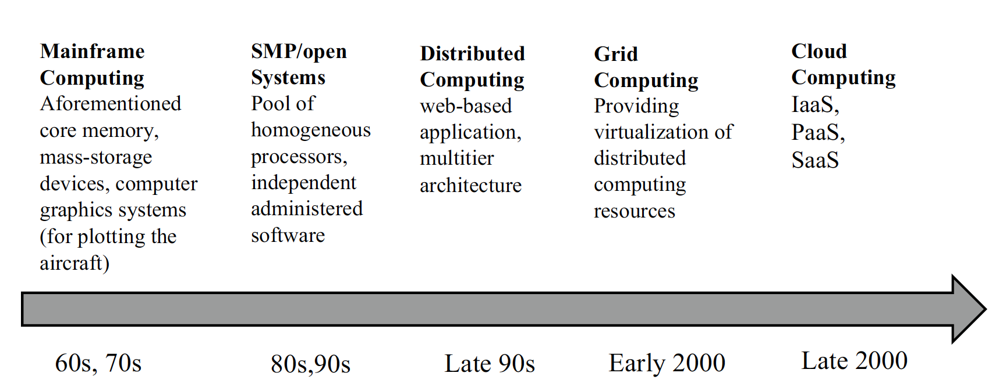Cloud computing - a model for enabling convenient, resource pooling, ubiquitous, on-demand access which can be easily delivered with different types of service provider interaction. The manageability, scalability, and availability are the main attributes of
cloud computing.
Service delivery models: software-as-a-service (SaaS), infrastructure-as-a-service (IaaS), and platform-as-a-service (PaaS).
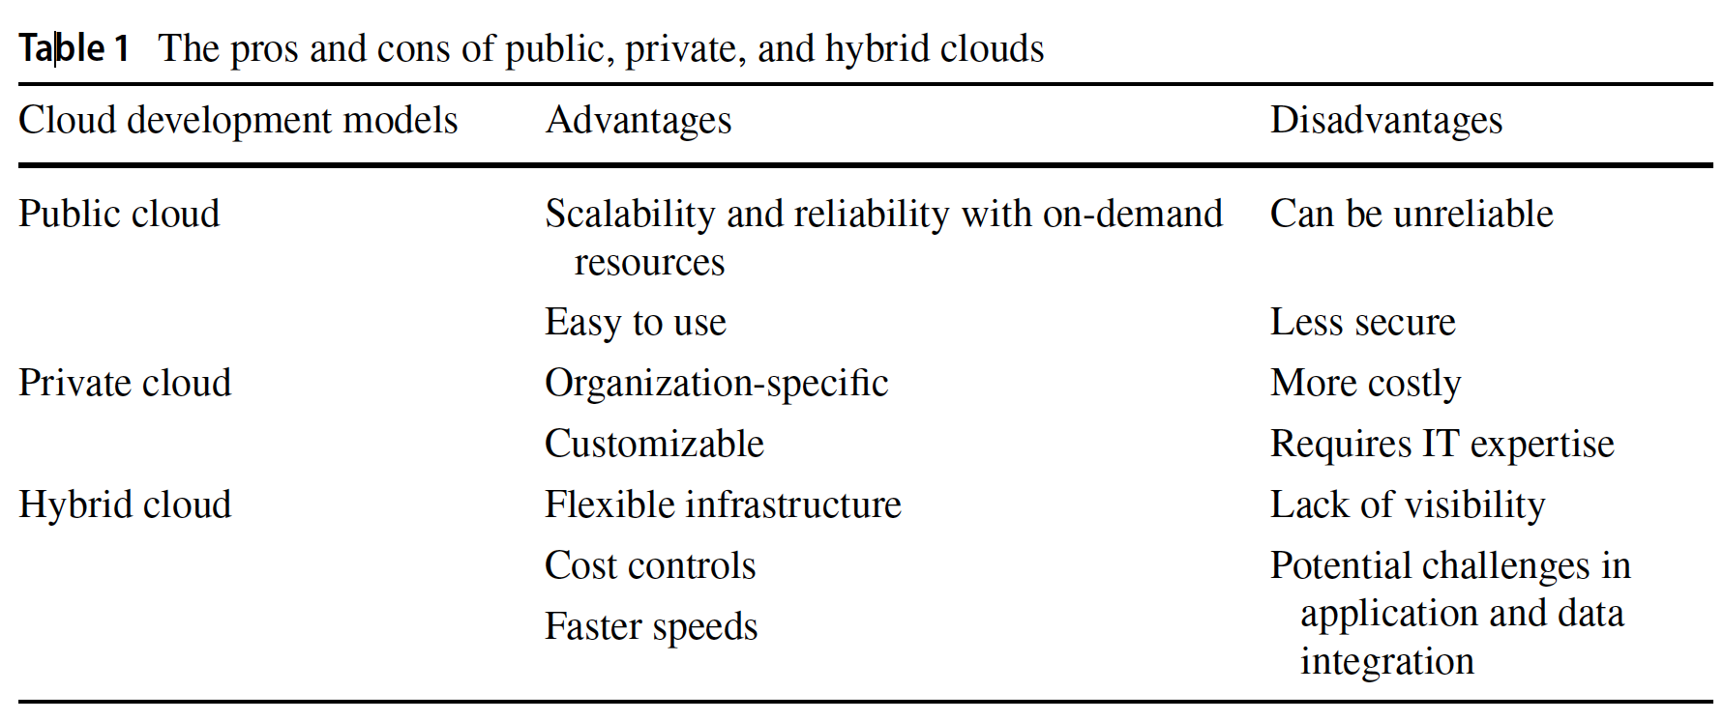
Cloud Delivery Model
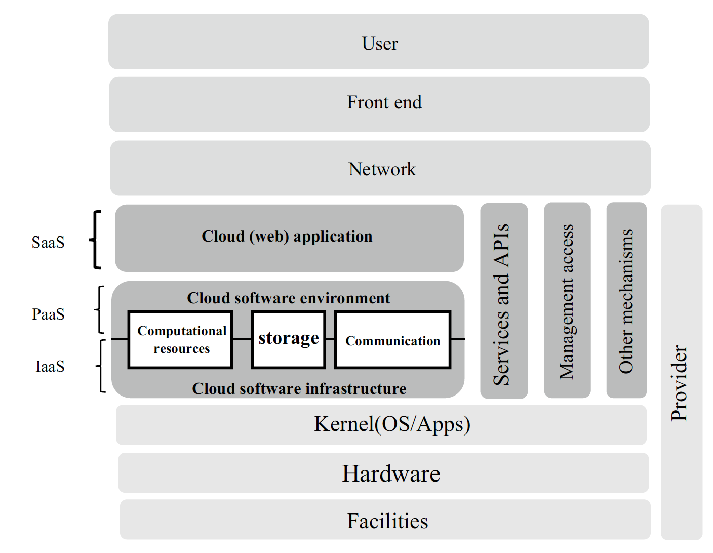
- Explain the cloud computing configuration model
Survey paper 2 - 2.1.2 Cloud configuration
Actors in Cloud Computing
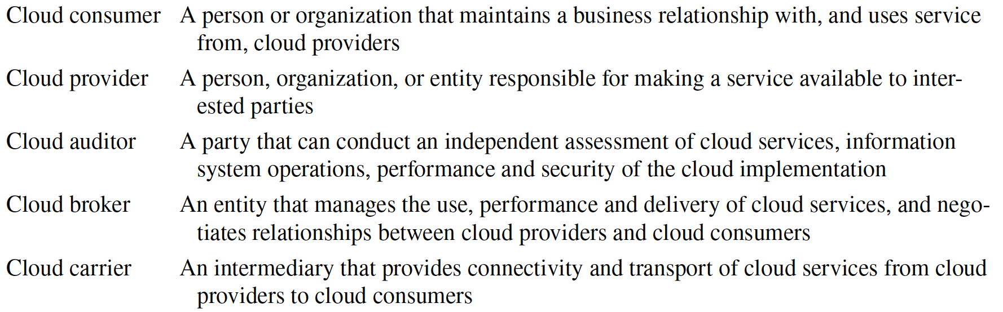
- Describe the cloud security issues and challenges
Survey paper 2 – section 3. Be able to recognize those security issues and challenges.
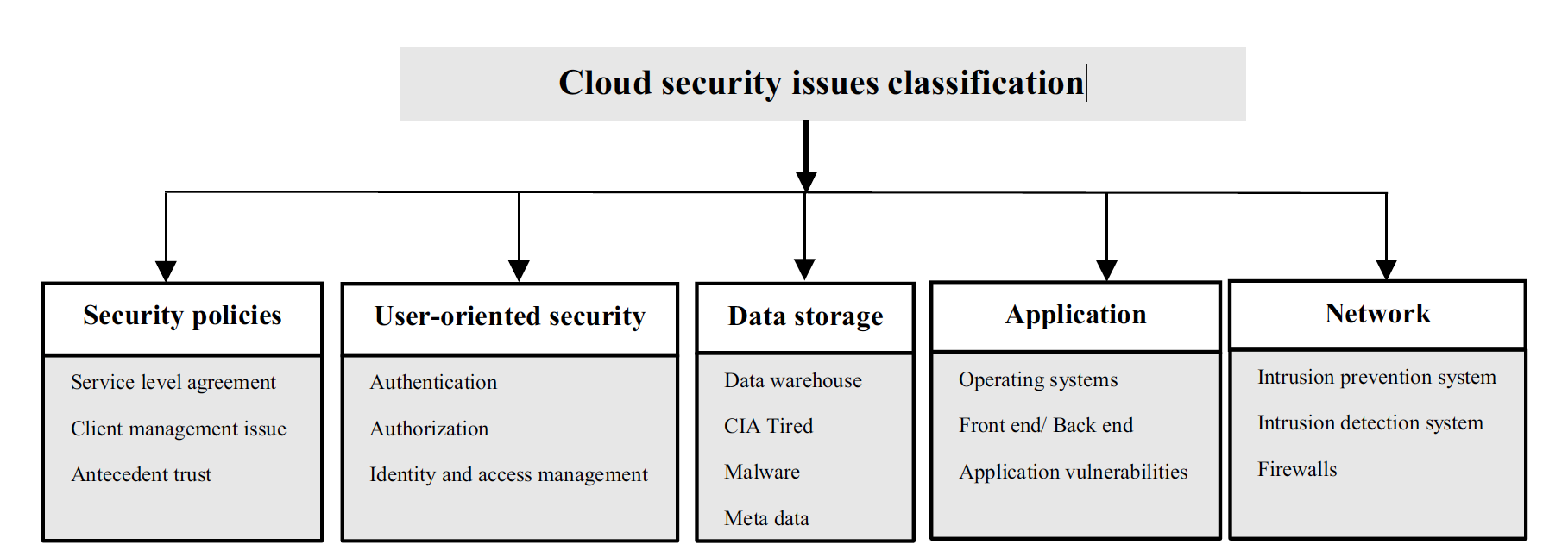
- Discuss the attacks and threats in cloud computing
Survey paper 2 – section 4. Be able to recognize the common threats and attacks in cloud computing.
